

**BSc (Hons) Computer Science and Software**

**Engineering**

UNIVERSITY OF BEDFORDSHIRE

HireBuddy : Online Automobile Service Platform

**Submitted by:**

**1727525**

**Nuwantha Fernando**

**Abstract**

There are thousands of vehicles moving around the planet daily with the intention of different tasks. But people are unable to do their day to day tasks because of many vehicle malfunctions like vehicle breakdowns and tire punctures. Even though there are several firms offer such services to repair vehicles they're ineffective to find the client and supply the service to them at the place of the cause. Therefore it can be terribly valuable if it's potential to try this, but sadly up to date there has been no state of affairs that has found an answer to the current situation. ”Hire Buddy: Online automobile Service Platform” is the best answer for everyone who face quite issues in their day to day life. Proposed system can be a replacement era of automobile repairing services as a result of this can be terribly fast, efficient and very low cost. Therefore the customers will be definitely satisfied with the proposed system. Through this system, the clients can easily request the service of the motor mechanic or tire technician related to their vehicle issue. Proposed Android device primarily based on reviews and skill of the service provider. So service providers will notify regarding the necessity of the customer. According to the required service and the location of the customer service team can attend the place as fast as possible. Also the projected system has a feature for the user to examine the time that takes for the service team to reach the given location. Our main approach is to build a user friendly application as well as a mobile application based on Android, to build a connection between the client, motor mechanic and tire technician.

**Acknowledgement**

I would like to express my special thanks of gratitude to my supervisor “Mr. Roshan Jayawardana” for his able guidance and support in completing my Project. I would also like to extend my appreciation to “Ms. Gayana Fernando” the lecturer accountable for Undergraduate Project for guiding me from selecting an appropriate research point until the last viva.

Secondly, I would also like to thank my parents’ colleagues who helped me a lot in finalizing this project within the limited time frame.

Special much gratitude goes to “Ms. Shahani Farwin”, who helped me and guided me to clarify the problems I confronted during developing the system.

**Dedication**

I finally dedicate my project to my family whose untiring support and assistance have made possible the fruition of my efforts. To my supervisor, Mr. Roshan Jayawardana and my lecturer in charge, Ms. Gayana Fernando.

**Contents**

**Table of figures**

Figure 1: Visually impaired per million population 2

Figure 2: Text detection and recognition process 8

Figure 3: Feature extraction process in detail 9

Figure 4: Detailed view of text to speech process 11

Figure 5: Image filtering methodes 12

Figure 6: Detailed comparison with currently existing products 15

Figure 7: Usage of smart devices for their health care 16

Figure 8: Graphical view of Spiral model 18

Figure 9: Process of requirement gathering 19

Figure 10:Daily engaging tasks 20

Figure 11: Total number of people 20

Figure 12:opinions about the system 21

Figure 13: GANTT chart 01 24

Figure 14: GANTT chart 02 24

Figure 15: GANTT chart 03 25

Figure 16: Work Breakdown Structure for the proposed project 26

Figure 17: Splash screen 27

Figure 18: Main interface 28

Figure 19: Interface with floating buttons 29

Figure 20:Usecase Diagram 30

Figure 21: Activity Diagram 31

Figure 22: Flow Diagram 32

Figure 23: graphical view of android platform 34

Figure 24: Code segment for import image from gallery 35

Figure 25: Code segment for capture image from camera 36

Figure 26: Result handling 37

Figure 27: process image to increase the quality 38

Figure 28:Correct the image orientation 38

Figure 29: Text recognition process 39

Figure 30: Recognized text set in to text view 40

Figure 31: Web search function 41

Figure 32: Calculation process 44

Figure 33: Text to speech 45

Figure 34:Speech to text 45

Figure 35: Testing methods 46

Figure 36:Performences of the application 63

Figure 37: Comments given by the users 64

Figure 38: Interview questions 74

Figure 39: Evaluation form part 1 75

Figure 40: Evaluation form part 2 76

Figure 41: Poster 77



vi | P a g e

**Chapter 01: Introduction**

This part of the report incorporates an introduction about the Final Thesis Report that contains the background, objectives and aims, framework of the proposed system as well as the structure of the Final Thesis report.

**1.1 Project Background**

In past few years there has been a significant increment of world population. And then the vehicle population is also increased parallel with the world population of people. With the day to day tasks people used to drive carelessly and because of that the vehicle accidents, vehicle breakdowns as well as tire punches are increased. This reality may squander the significant time of the general population and therefore they neglect to oversee and to complete their day to day activities on time. Along these lines, People need a decent answer for this issue. Most insurance agencies offer few arrangements, however those are not much practical. This project expects to build up a portable application dependent on Android that guides people to get the help of a proper person around the area to repair the vehicle's disappointment.

Breakdown cover service is a helpful strategy for roadside fixes if the vehicle failures while people are out on the town. This implies a prepared specialist will come to fix the vehicle. Having the correct breakdown spread can get the general population out of inconvenience and spare the cash. This kind of service could be the best alternative if people drive far, or if people just drive once in a while. If people are on a problem of spending more, the mechanic will give them a reasonable cost and these sorts of spreads are valuable if people are facing many difficulties with their unreliable vehicle that might not start, or if they are far away from a garage.

"Hire buddy" isn't only for help from a professional but also it offers a lot of features to the client such as accessing to the insurance portal directly as well as offering a cost calculator. By utilizing "Hire buddy" the client ready to get free calls with the specialist, just as it gives a cost adding machine and access to the protection entrance specifically. Future more, the application will give information to the nearest police stations, nearest hospitals as well as the nearest insurance agencies. Moreover, the proposed framework will be beneficial for every single person to expand their efficiency while diminish the outstanding task at hand.

**1.2 Aim and Objectives**

**Aim**

The purpose of this proposed framework is to build up an android based mobile application which guides the client to get the help of the appropriate person nearby to fix the vehicle disappointment.

**Objectives**

* To find existing comparative virtual products and distinguish the short comes of them, which can incorporate as an exceptional element of the framework.
* To distinguish dangers which happened when the implementing the application
* To plan and execute a calculation to calculate the expense of the required customer service.
* To build up a product which will regularly use by the client.
* To assess the advancement of the proposed framework by executing a trial.

**1.3 Project framework**

First of all, to confirm that the proposed framework is attainable, look into papers, surveys and articles were evaluated just as case studies was finished. With the assistance of these articles, information of the foundation of the proposed framework and learning about the current mechanical circumstance was picked up.



I made a questionnaire to assemble primary information and distributed it on social gatherings. To gather secondary information articles have been audited and required programming was chosen. There after by utilizing this examined information it chooses the unique features for the framework and also the other suitable features were chosen. At last the Methodology or the life cycle model chose by accomplish the final item of course and to convey a helpful framework with regards to the gathered primary information.

Work Breakdown Structure was build to get clear thought of the proposed framework, and use case chart was controlled to distinguish the inside foundation of the framework. The Gantt chart was build to take the proposed system in the timeline.

Proposed framework will create utilizing Android Studio and Agile Methodology chosen as the life cycle demonstrates. With regards to the Agile Methodology the proposed framework deliver sprint wise.

**1.4 Structure of the report**

In this, The Final Thesis report of “HireBuddy” android based mobile application will consist of 5 main chapters as mentioned below.

1. Introduction
2. Literature Review
3. Methodology
4. Results and Discussion
5. Conclusion

**Chapter 1: Introduction**

This is the main chapter of this Final Thesis Report which explains the overall context of the project background, the reason for choosing such a matter as the subject and the outcomes of the proposed framework. The introduction on Aims and Objectives gives an idea of the proposed framework that finally going to accomplished. And furthermore Project Framework is giving brief depiction about how phases of software development life cycle are including with the proposed framework.

**Chapter 2: Literature Review**

The second chapter of the report is “Literature Review”. This can be consider as the most valuable chapter of the report. It provides detailed explanation about the researched areas which investigate to complete this proposed system successfully. And also this chapter gives a detail comparison between similar existing products and the “HireBuddy” application to prove its uniqueness and the accuracy.



**Chapter 3: Methodology**

This section will disclose the methodology picked to build up the framework, gathering and analyzing of primary and secondary data, the arrangement of the project with significant outlines and charts, pertinent framework graphs and the underlying plan of the framework as well as the implementation details and code segments.

**Chapter 4: Testing and Results.**

Test cases and the results of them are included in this chapter. The screenshots of the obtained results during the testing also included as required evidences.

**Chapter 5: Evaluation**

This section will incorporate how the evaluation as well as the critical discussion based on the evaluation of the framework is done.

**Chapter 6: Conclusion**

As the final chapter of this report it gives an overall idea about the proposed system and the importance as well as the benifits of it. Basically this chapter includes an explanation about the limitations and the developments that can be added to the system in the future.



**Chapter 02: Literature Review**

This section includes the reviewed literature and the applicable extraction for this exploration, from the current available literature connected with “Hire Buddy: Online Automobile Service Platform”. The section is additionally subdivided dependent on the title of the each research paper.

**2.1 Introduction**

Vehicle disappointment can present as a mechanical disappointment happened in the engine vehicle and these sort of issues are make the vehicle from being worked and furthermore it cause obstructs the task of the vehicle to such an extent. These issues are very difficult, dangerous or else impossible to operate. There are different reasons to a vehicle breakdown on the road, for example,

* Battery Failures
* Fuel Problems
* Mechanical Problems
* Tire punctures
* Charging Problems for Electrical Vehicles
* Electrical Issues
* Clutch Issue
* Heating, Ventilation, Air conditioning and cooling issues.

Some people have the technical knowledge to manage such kind of vehicle failures. But most of vehicle users don't have a proper technical knowledge. At the moment when vehicle need a repair the majority of the vehicle owners with money difficulty or their busy life timetable may take longer than they should take important fixes made to their vehicles. Due to that expanding threat or else causing more harm.

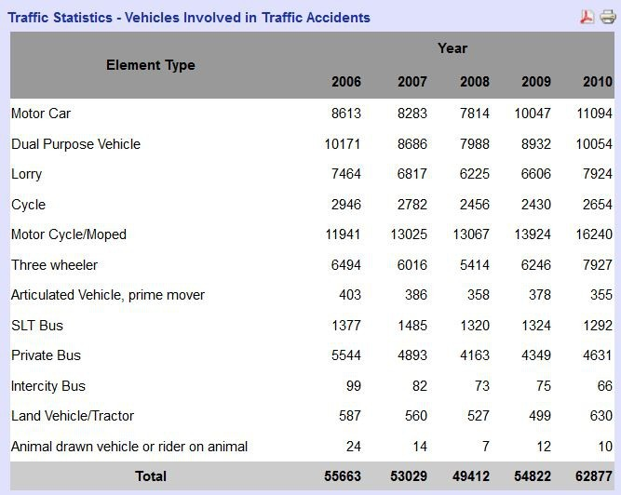

*Figure 1: Sri Lanka Traffic Statistic*

According to the results, vehicles associated with traffic accidents expanded in following component types.

|  |  |  |
| --- | --- | --- |
| Motor Car | 2006 - 8613 | 210 - 11094 |
| Lorry | 2006 - 7464 | 2010 - 7924 |
| Motor Cycle | 2006 - 11941 | 2010 - 16240 |
| Three Wheeler | 2006 - 6494 | 2010 - 7927 |

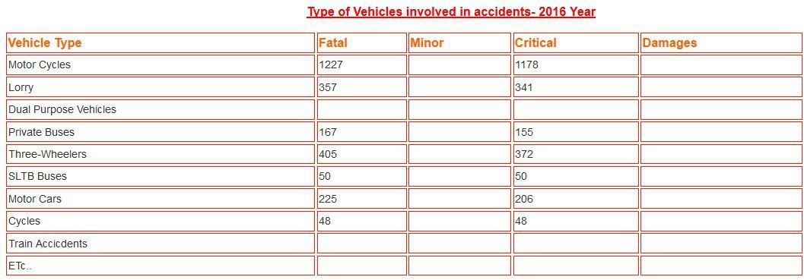

*Figure 2: Sri Lanka Vehicle involved in accidents 2016*

*Figure 3: Sri Lanka Vehicle involved in accidents 2017*

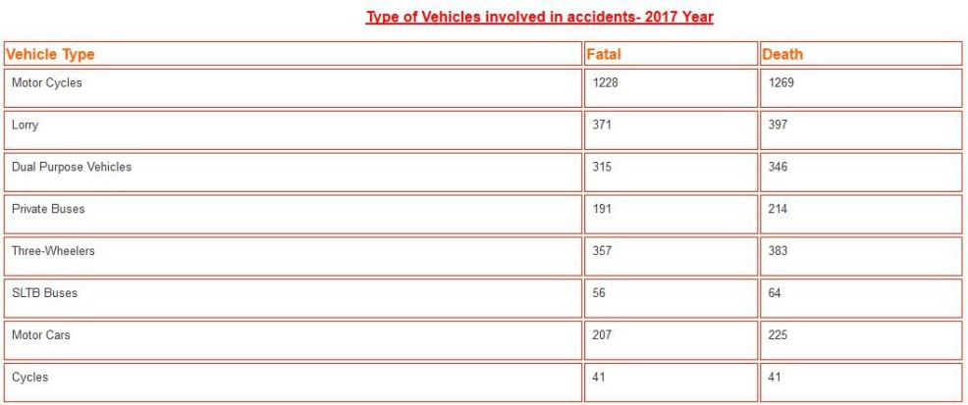

When looking at the year 2016 and 2017 Motor Cycles, Lorry and three wheelers can be consider as the vehicle types which mostly involved in accidents.

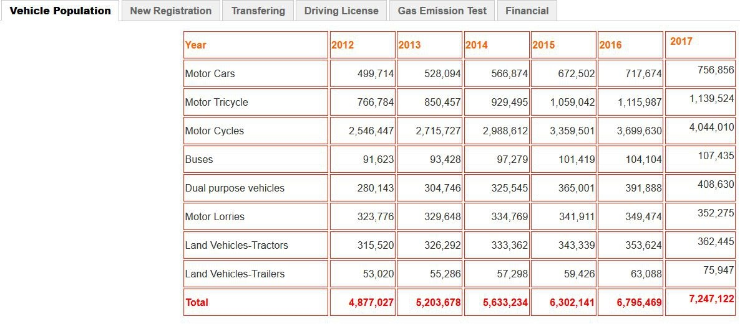

*Figure 4: Sri Lanka Vehicle Population*

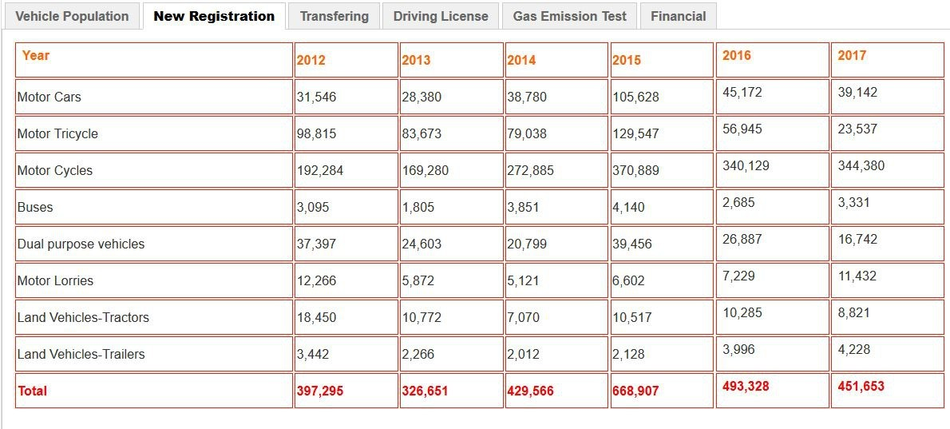

*Figure 5: Sri Lanka Vehicle Registration Statistics*

As per the outcomes, Motor cycle populace has expanded from year 2012 to 2017. The purposes behind the for the most part included vehicle in street traffic mishaps are exceptionally clear because of this and furthermore, new enrollment for the engine cycles is expanded structure year 2012 to year 2017.

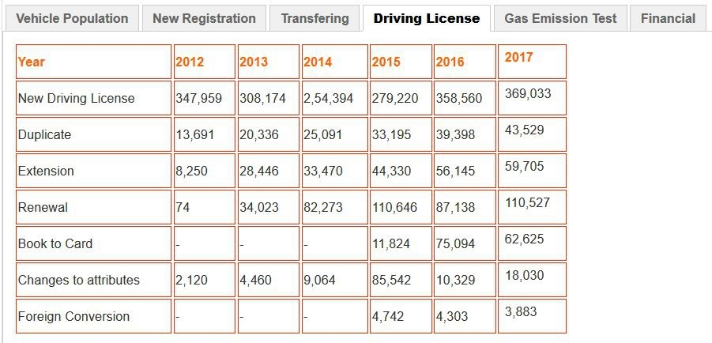

*Figure 6: Sri Lanka Driving License Issue Records*

Automobile Service Unit as well as automobile servicing and repairing is a most customarily known activity in every single urban district where a wide scope of motor vehicles like jeeps, Lorries, cars, three wheelers, buses, Motor bikes etc are given for fixes and administrations.

For a safe driving and sturdiness of the vehicles it is required to have a standard maintenance as well as a support. Fail to maintain the vehicle properly, current condition of the streets, thoughtless driving, utilization of low valued and low quality spare parts, and so on are the noticeable motivations to which vehicles are directed to repairing. Due to such kind of issues Service station has become a most significant requirement to vehicle users. This unit can be set up in urban, semi-urban and town areas to meet the nearby necessities. Contenders are having extraordinary experience or qualified people who can start this unit with low speculation.

**Review of the Scholar Articles**

**Vehicle Services Report Network**

The four investigators did an investigation on “Vehicle Repair Network”. To ﬁnd out how people work when the vehicle breakdown happened to them. What people normally do is, they looking services for their harmed vehicles by using phone directories and ﬁltering through various listing of repair services so as to ﬁnd the suited one. Hence people will search for a business that will beneﬁt the particular type of vehicle; one that gives the type of service which the vehicle needs, and one that is situated in the geographical zone need by the generals

After inspected those types of situations they understood, that they require a procedure and framework that will allows people to simply and efficiently arrange service for their vehicle? Ideally, this procedure should return a list of details about available services and repair stations in the searched area.

So agents think of an answer, that is a framework and strategy are described that give the chance to the people to shop on-line for service businesses that will ﬁx the damaged vehicle. The framework gives a display screen that catches data identifying with the vehicle requiring service and transmits that information to responsible. The service business reacts to the transmitted information by sending an estimate for the repair work to the framework. A custom web page that shows the all the estimates were produced by the framework and a l ink to that web page mailed to the people.

(Michael Lowell, Donald Wolfe, Doug Nottage, Michael Blair, 2002)

The overall network diagram which they have used for Vehicle Service Repair Network is shown below,

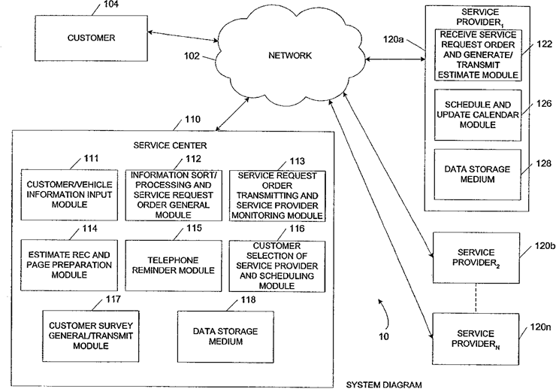

*Figure 7: Vehicle Service Repair Network*

vehicle identiﬁcation number, from the database. And when they sending the vehicle information and a graphical representation of the vehicle damage, including the selectable vehicle damage locations, over the network to the customer computer machine, and they receive back the selection of at least one vehicle damage location over the network from the customer computer machine, and also receive back at least one image of the vehicle over the network from the customer computer machine, storing the vehicle information, where the selected damage location and the vehicle image as a repair job to the database, and again sending the notiﬁcation, including that the new repair job is available for review, over the network to at least one repair provider computer machine.

(Ingrid cook, 2010)

Their process can be described as in the following diagram,

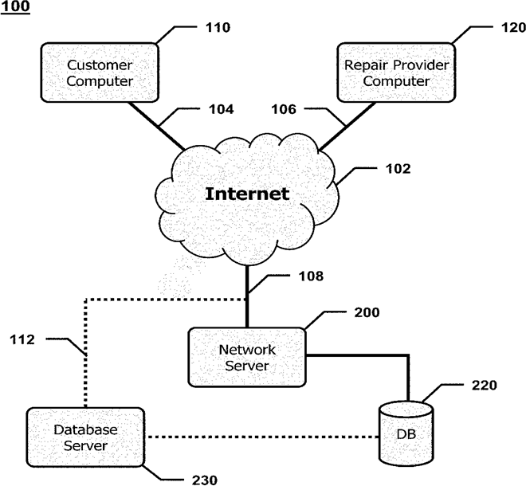

*Figure 8: Vehicle Repair Cost Estimate Acquisition System Network*

**Equipment Service Vehicle with network-assisted vehicle service and repair**

The two investigators did an investigation on “Equipment service vehicle with network- assisted vehicle service and repair”. To find out how to provide a more efficient vehicle maintenance for the customers, because modern vehicles are become complex and difficult to maintain nowadays.

After examined those factors they introduce “A method of ordering parts for an equipment service vehicle comprises performing a diagnostic test on the equipment service vehicle”

The previous step is done through a computer system on board a service vehicle and a request for a replacement part is transmitted for a service vehicle. The device, radio frequency combines a workbench that is compatible with the computer and the computer system.

A method for programming the maintenance of an equipment service vehicle comprises performing a diagnostic test on the equipment service vehicle using a computer system on board the equipment service vehicle, and transmitting an application to program the service vehicle of the equipment. The request is transmitted from the computer system of the vehicle on board to an external computer system through a radio frequency wireless communication link.

(Duane R. Pillar, Bradley C. Squires, 2006)

**Vehicle repair cost estimate acquisition system and method.**

An examiner from US completed an examination on Vehicle Repair Cost Estimate Acquisition System and Method. To find out a strategy for computing fix gauges for vehicles. Since present day vehicles are turned out to be intricate and difficult to look after these days.

After inspected those components the agent execute a PC based technique for getting fix gauges for a vehicle, and a related system server, are given. The strategy is reclaiming a vehicle identification number over the system from the client PC machine and reclaiming vehicle data where related.

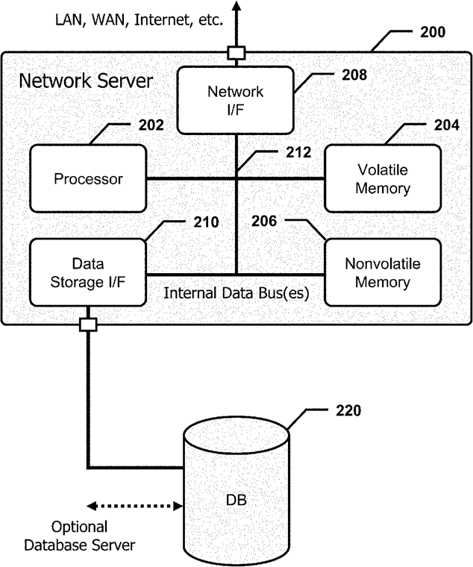

*Figure 9: Vehicle Repair Cost Estimate Acquisition System Database*

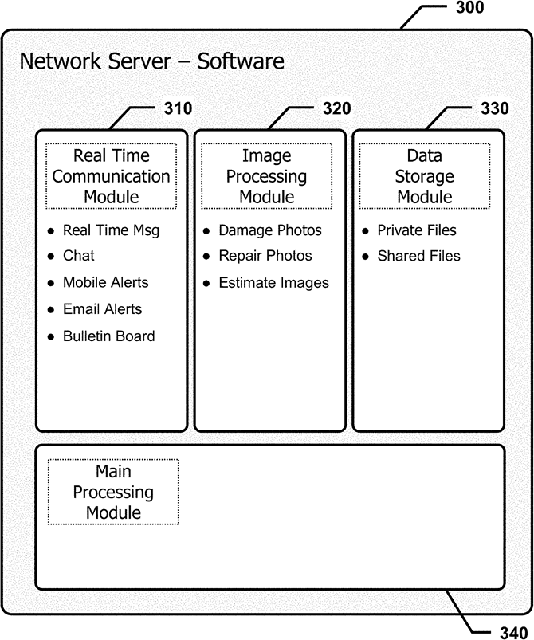

*Figure 10: Vehicle Repair Cost Estimate Acquisition System Network Server*

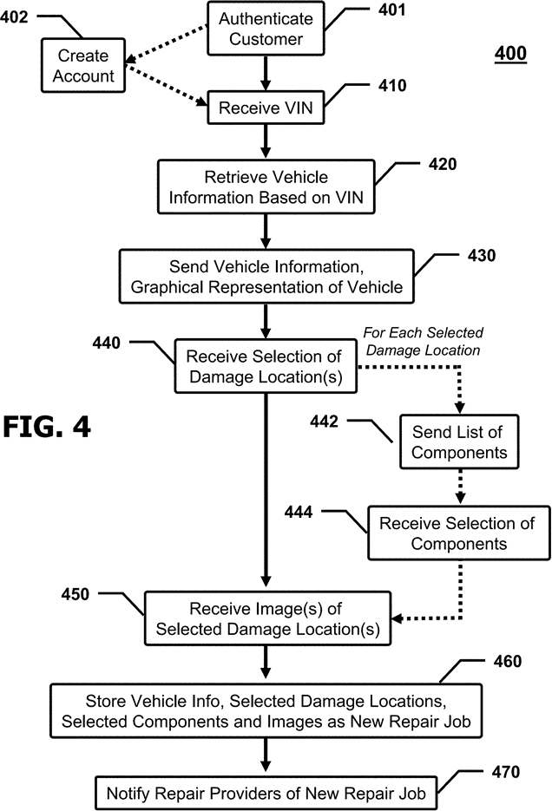

*Figure 11: Notify Repair Provide Process*

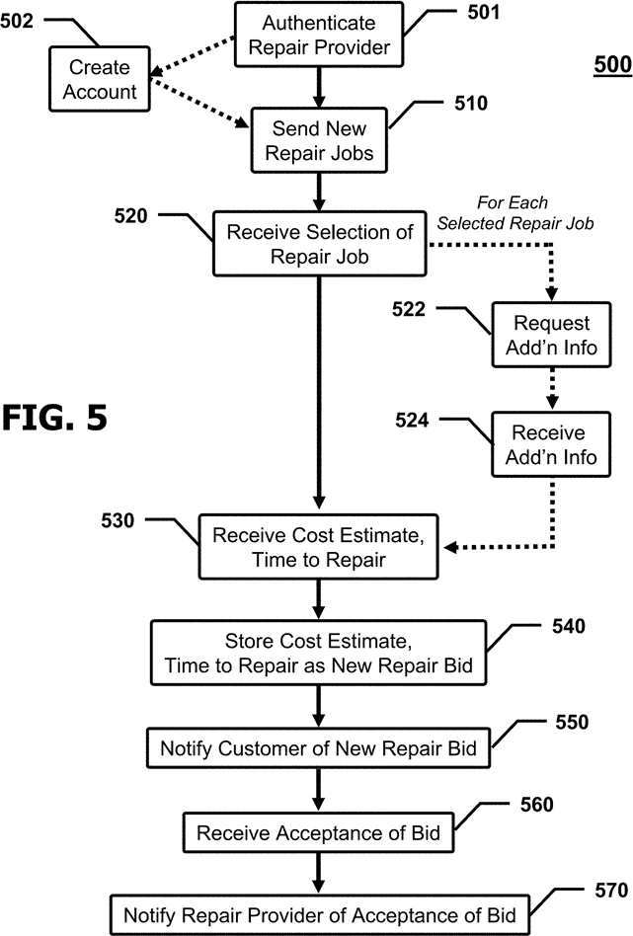

*Figure 12: Notify Repair Provide of Acceptance Process*

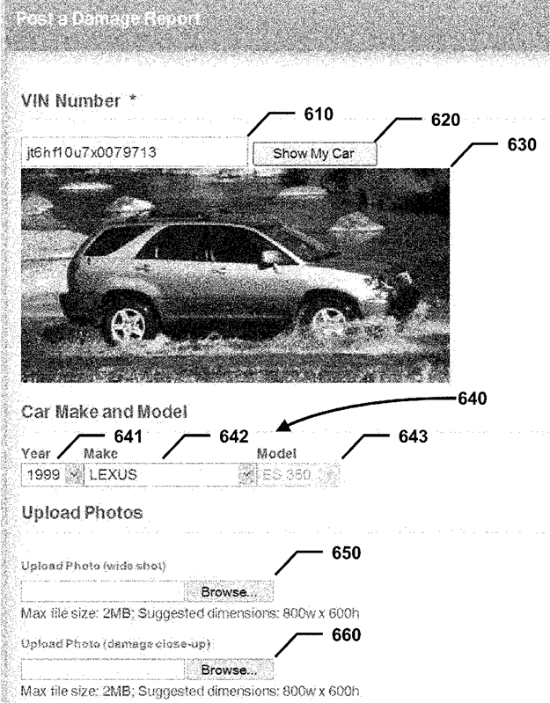

*Figure 13: Damage Report Post GUI*

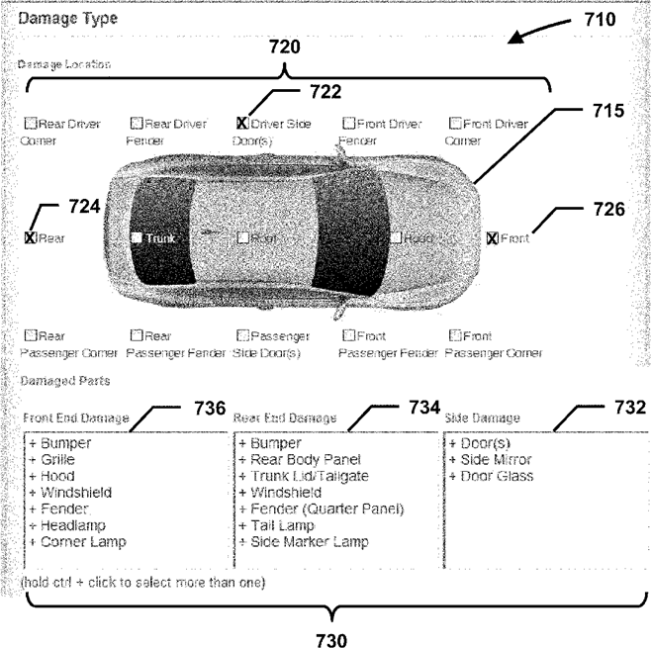

*Figure 14: Damage type Select GUI*

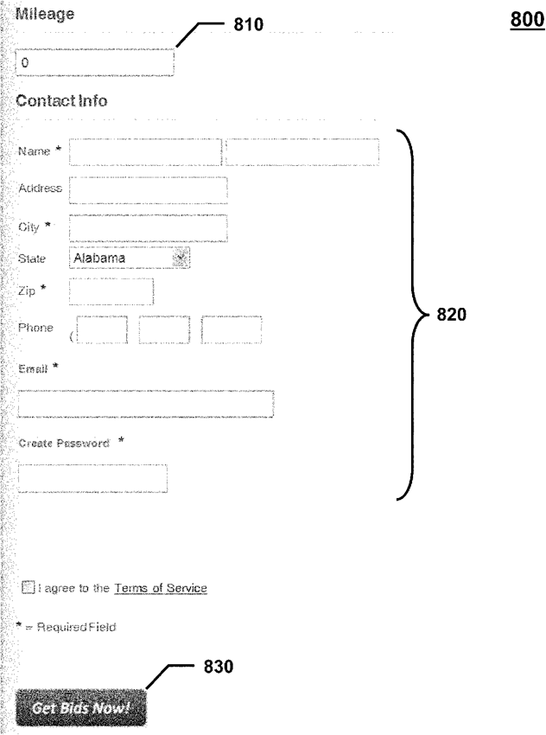

*Figure 15: Mileage Select GUI*

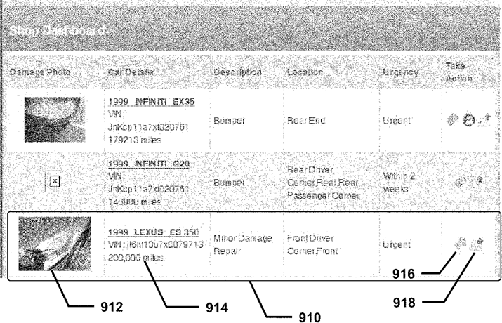

*Figure 16: Shop Dashboard GUI*

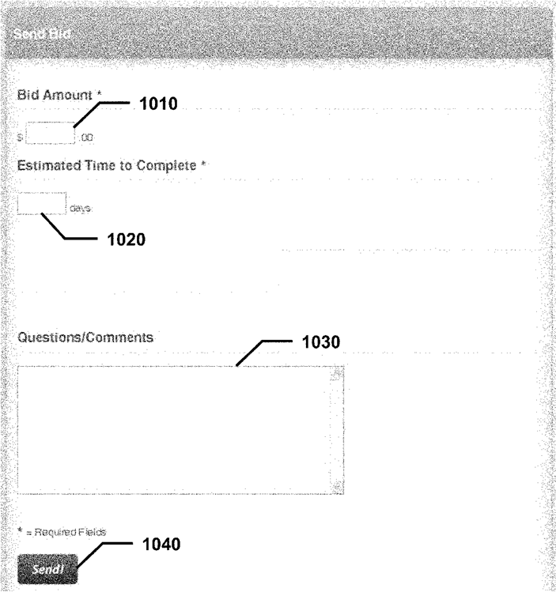

*Figure 17: Shop Bid GUI*

**Conclusion**

As appeared by the Literature Review which was done, this gathers how p automobile service platform assistanc which be proﬁtable just as positive audit. Since Now a days the majority of the general population confronted such a significant number of basic occurrences when their vehicle been harmed when they travel or drive. So using this application will be the easiest way to most of the people, rather than ﬁnding repair services by utilizing telephone registries and ﬁltering through different posting of fix benefits in order to ﬁnd the most suitable one.

According to the literature review it analyzes the proposed framework and the current frameworks. The Proposed framework is by and large where a client to ﬁnd a automobile service for their vehicle breakdowns as opposed to opening phone directories to ﬁnd out the repair stations and go to road by road to ﬁnd the suitable service aid.

**Chapter 03: Methodology**

**3.1 Introduction**

There are several kinds of methodologies that can be used for the development of mobile application. But there are strengths and weaknesses in all the methodology types.

So Agile Methodology was used for the proposed Online Automobile Application based on Android. Agile Methodology is highly recommended and known as a “gold standard” methodology in the market as it follows an iterative approach.

The purposes of choosing the Agile Methodology is by separating Implementation of the proposed framework in to sprints is going to help being developed and furthermore it is not normal for customary application advancement models, in here does not test the application at the final improvement stage. The Agile Methodology approach likewise gives the designer to modify the advancement procedure. There's no a specific method to make an application. It permits creating and launching the mobile application in different ways.

The below figure will help to identify how the agile Methodology works.

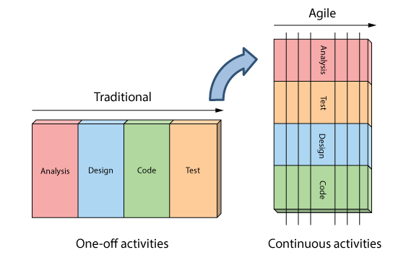

*Figure 21: Agile Comparison Chart*

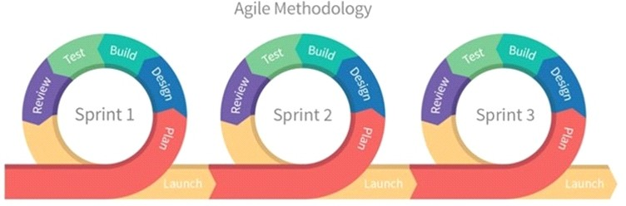

*Figure 22: Agile Methodology*

.

We can divide a project into “sprints” (Sub Parts) by using Agile Methodology. Sprint developments are done on iteratively as well as there is a deadline for each project.

As soon as a sprint completed, developer must have a testable potential product. It means Agile helps to create the project easier as well as it creates a product which suits to developers needs while minimizing complexity. The sprint duration is always fixed. That guarantees developers can regularly review the project's direction and keep it on track.

Below table gives an idea about the advantages and the disadvantages of the Agile Methodology.

|  |  |
| --- | --- |
| **Advantages** | **Disadvantages** |
| Faster turnaround times.  Able to detect and fix issues and defects faster.  There is a large community of agile practitioners whom are ready to share knowledge.  Don't have to worry about premature optimization.  Able to experiment and test ideas because it costs are low.  Deploy software quicker. | Hard to measure the progress.  Project can be ever-lasting because there’s no clear end.  Features that are too much to ﬁt into one or even several sprints are avoided because they don’t fit into the philosophy.  Need to long term vision for the product and actively work on it.  Hard to measure the actual cost of the project. |

**Planning of the system**

**Current plan and progress**

For do the arranging of the proposed Hirebuddy framework Work Breakdown Structure was designed. WBS can be considering as a main component which helps to manage and organize the project work. WBS makes the project understandable and by breaking large tasks into small partitions it helps to manage WBS is not restricted as well as it can be able to use for any type of project.

Time management is also an important thing. In the purpose of making the achievements a success, time was planned perfectly. The Gantt chart was designed to plan the time. It will lead, through the whole venture to be done flawlessly. Gantt chart is following the Agile methodology. According to Agile Methodology, all kind of project related woks will be arranges as well as planned successfully.

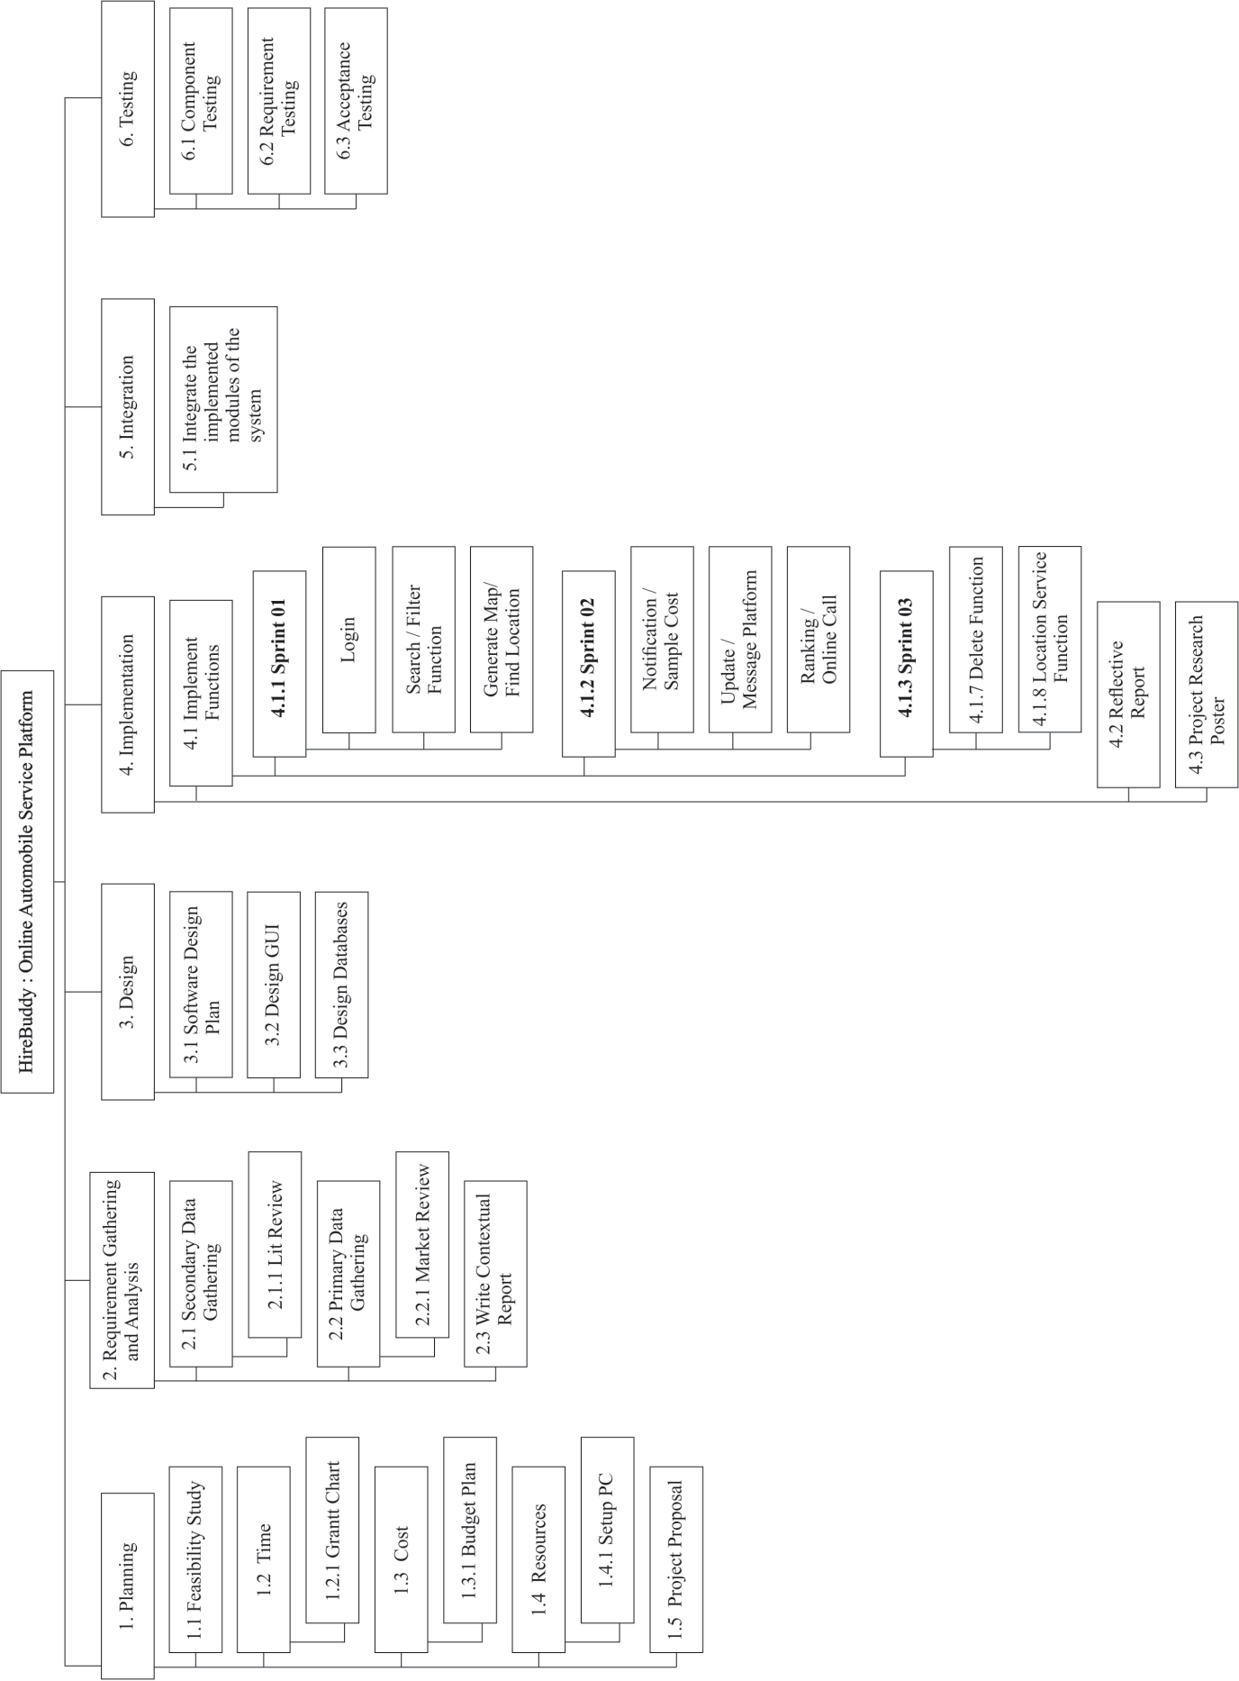

*Figure 20: Work Breakdown Chart*

**3.2 Requirement gathering and analysis**

Requirements gathered as primary and secondary data. Primary data collected by creating a questionnaire using “Google forms”. It was shared in social media groups to collect data. Shared questionnaire included with some questions which supports for the development.

The questionnaire which provided to analyze answers was shown in below.

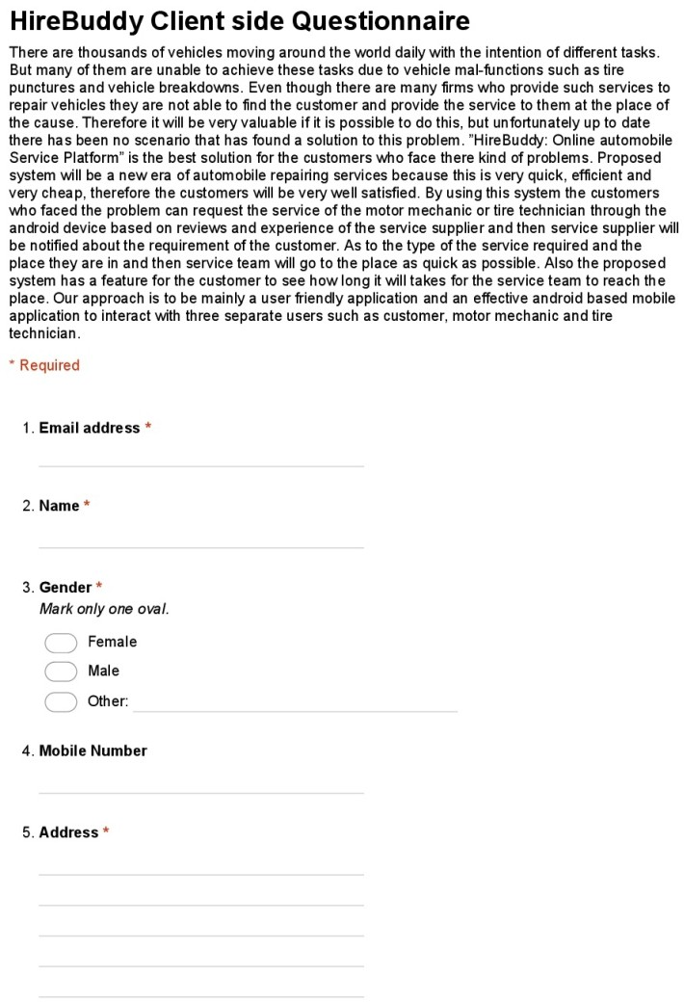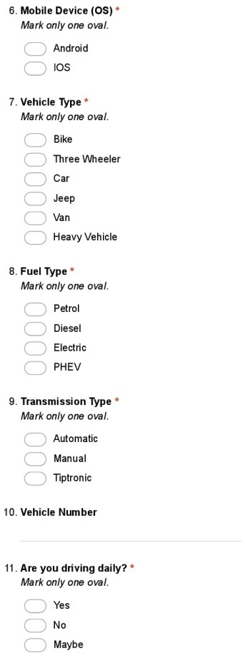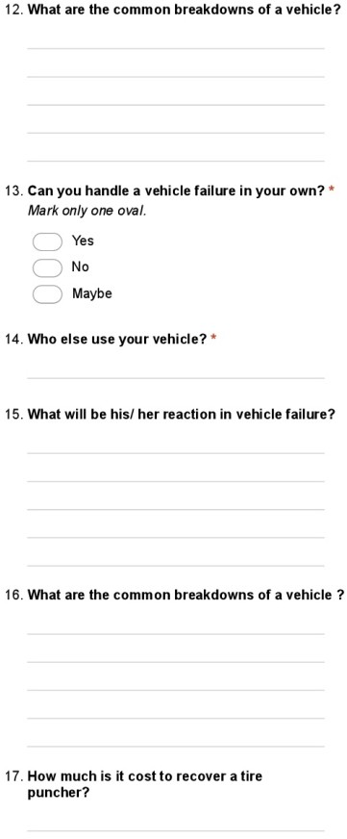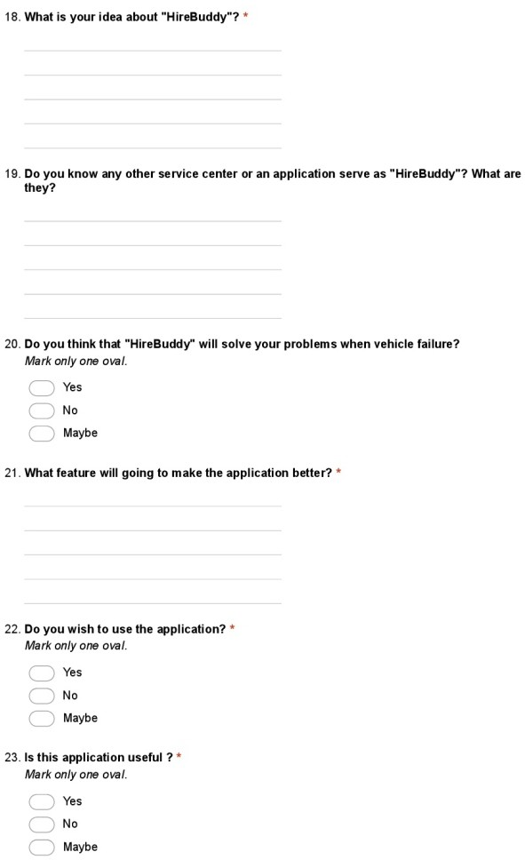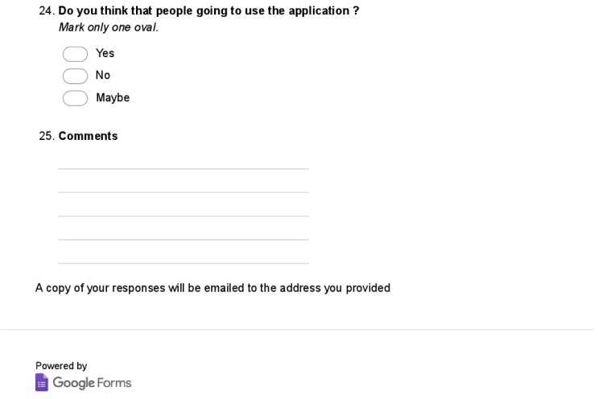

*Figure 23:Questionnaire*

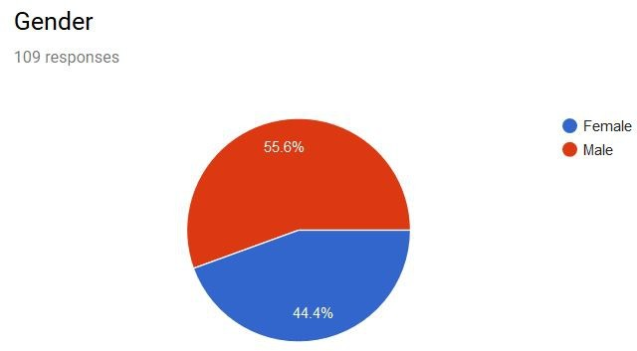

*Figure 24:Question part 01*

This figure shows the percentage of the vehicle usage of males and females. So as indicated by the above examined information it demonstrates that vehicles are generally utilized by males. As well as the use of vehicles of females additionally achieves about portion of the graph.

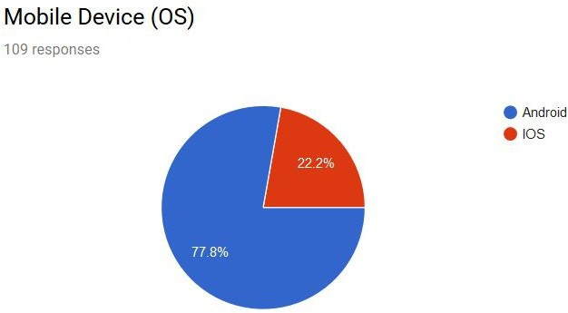*Figure 25:Question part 02*

As the ﬁgure appears over, most of the general population use Android based cell phones. Not many use ISO based mobiles.

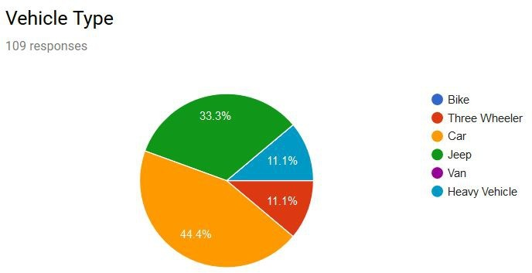

*Figure 26:Question part 03*

The above figure which demonstrates the vehicle types shows "Car" as the most trade-in vehicle type. The second spot taken by Jeeps while the third spot take by "Three Wheelers" and "Heavy vehicles" similarly.

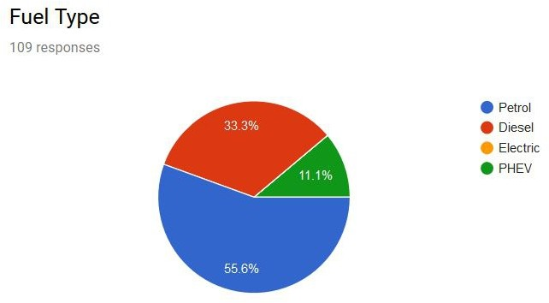

*Figure 27:Question part 04*

Petrol is generally the most utilized fuel type as per the above diagram. Furthermore the second place goes to diesel and then PHEV and Electric vehicles are less.

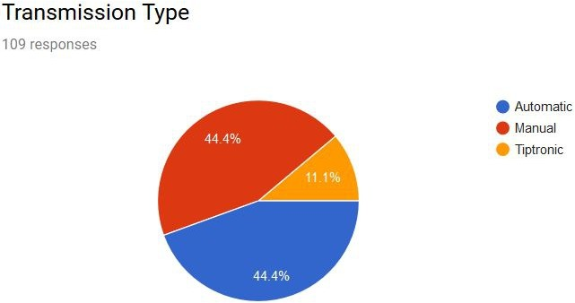

*Figure 28:Question part 05*

As indicated by the above broke down information Automatic and Manual Transmission types happen as greater part. Not many have the Tiptronic innovation.

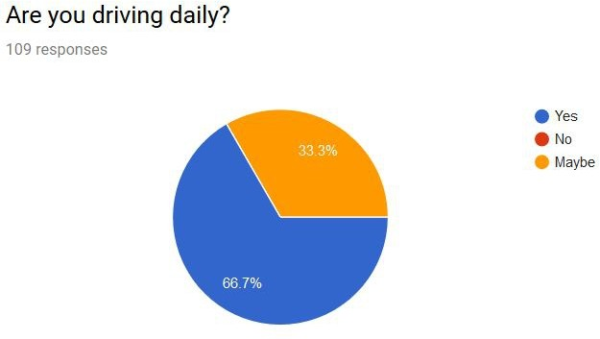

*Figure 29:Question part 06*

The majority are driving day by day as indicated by the above diagram. It’s hard to find a person who is not driving daily.

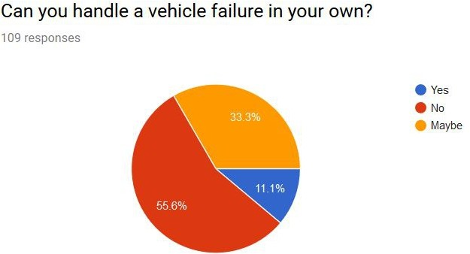

*Figure 30: Question part 07*

As the above figure demonstrates the majority of the general population can't deal with a vehicle disappointment in their own. No one but few can deal with a little yet most need the assistance of a technician.

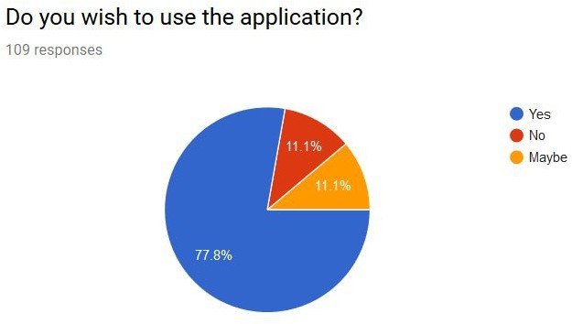

*Figure 31:Question part 08*

As indicated by the figure a large portion of the general population wish to utilize this application According to the dissected information.

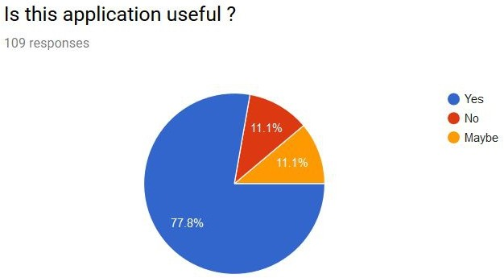

*Figure 32:Question part 09*

As the above chart it demonstrates that a great many people figure the application will be helpful for everybody in their everyday life.

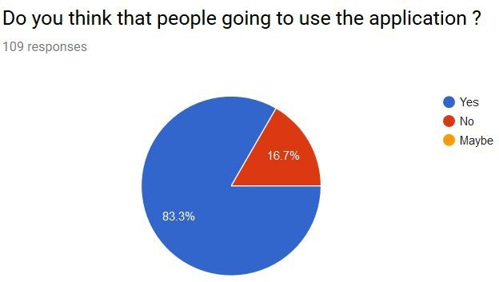

*Figure 33: Question part 10*

As indicated by the broke down diagram the larger part said "yes" to this inquiry. It implies a large portion of the general population believe that everybody will utilize this later on just as it will be extremely helpful.

**3.3 Design**

This section is the most important part of developing. Framework was planned so as to satisfy the necessities. This undertaking was done in 3 sub stages such as

* System Design
* Interface Design
* Database Design

**3.3.1. System Design**

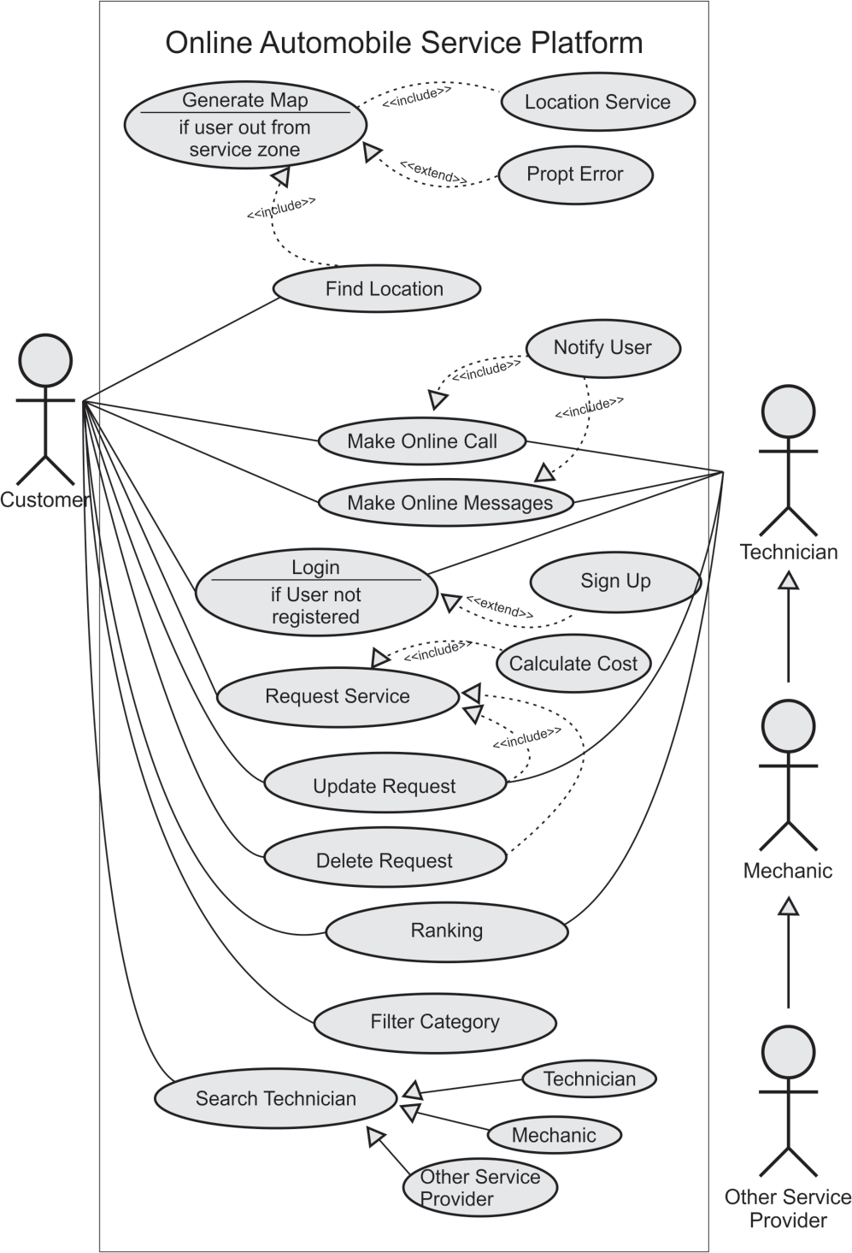First of all, the use case diagram designed to describe the functions of the system. It helps to specify a desired behavior of the proposed system and identify communication between system and the external entities.

*Figure 34:Use Case Diagram*

High-level architecture diagram gives a general thought of the framework.

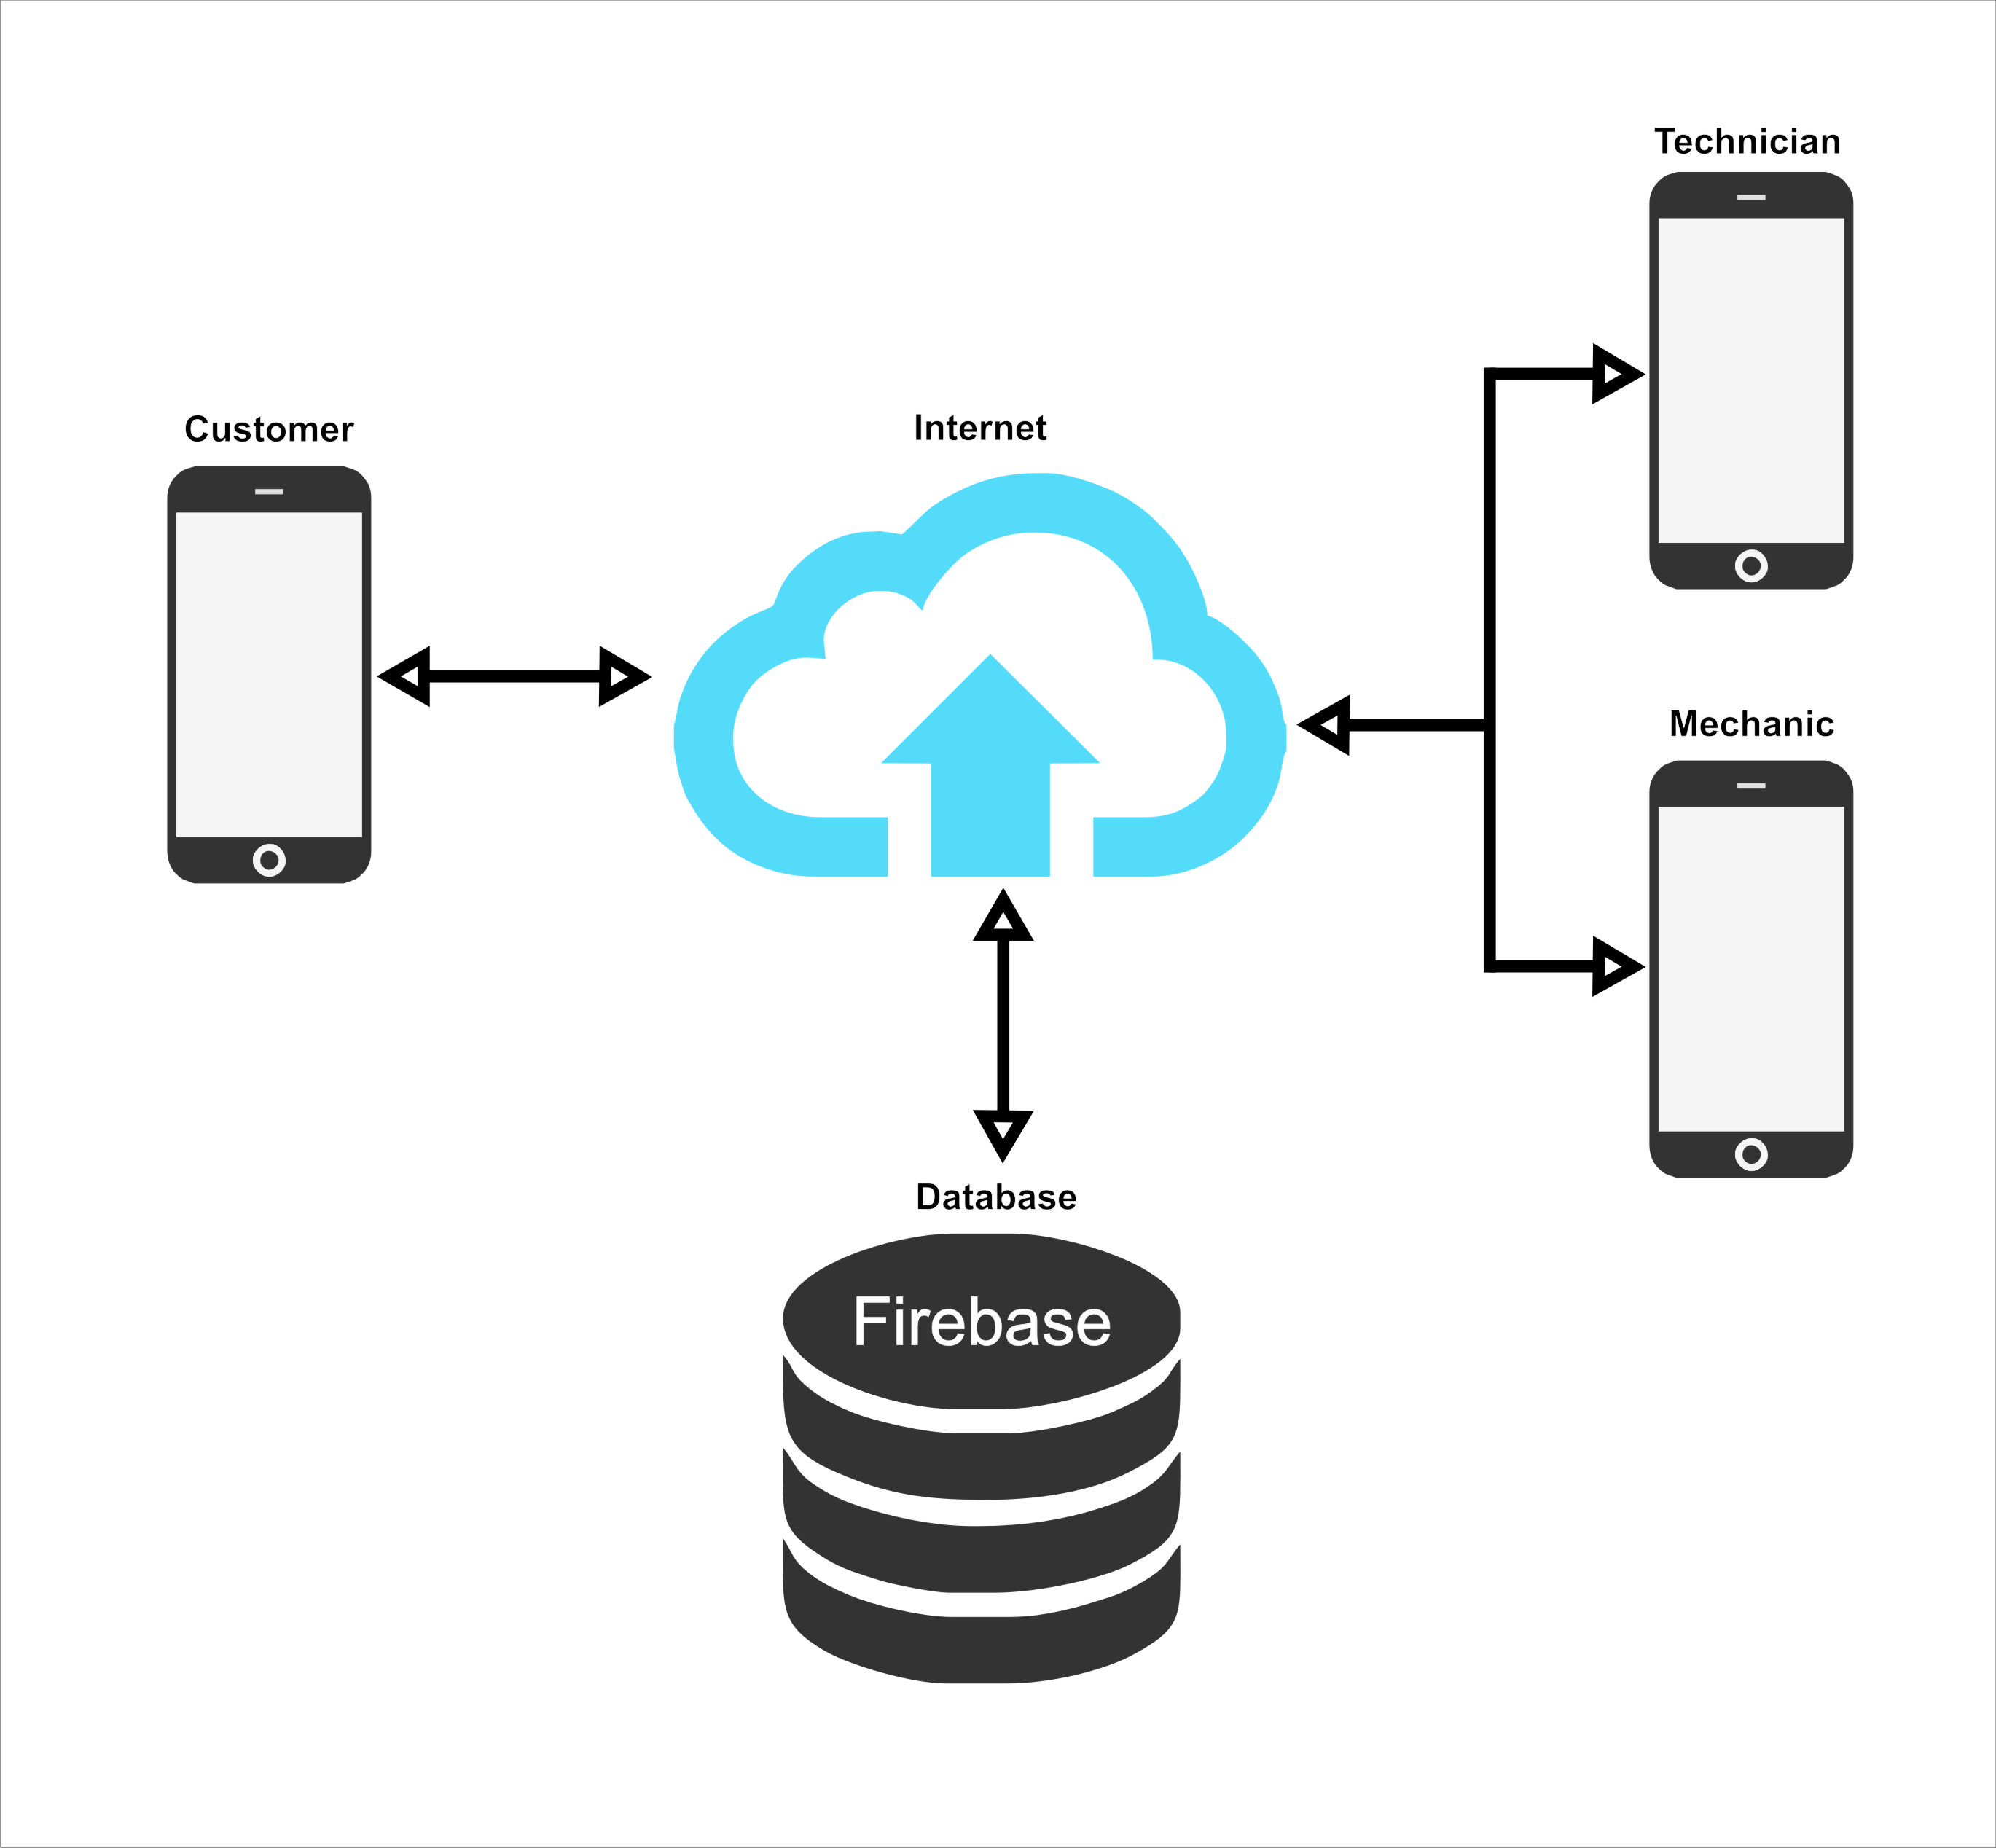

*Figure 21 High-level architecture diagrams*

**3.3.2. Interface Design**

All the interfaces of the HireBuddy application were designed using a user-friendly manner. Since the HireBuddy application is commonly used by many sorts of people the appearance of the interfaces is significant and it must be more attractive and simplistic as well as it will urge a different kind of people to use this application in their daily activities.

The application icon is build up with the application logo and attractive color variants. When compares with the professional level applications the HireBuddy icon is also at a top level.

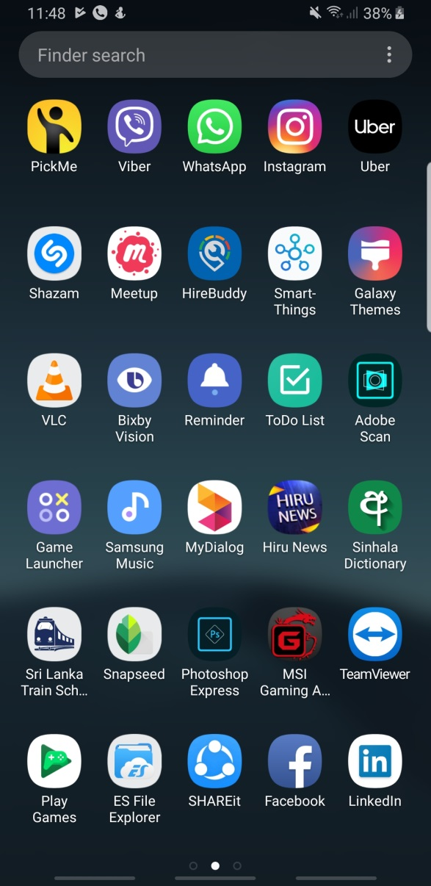

When starts the application the user will be navigated to the welcome screen of the application. It consists of animating application logo and after a few seconds, the user selection screen will automatically appear.

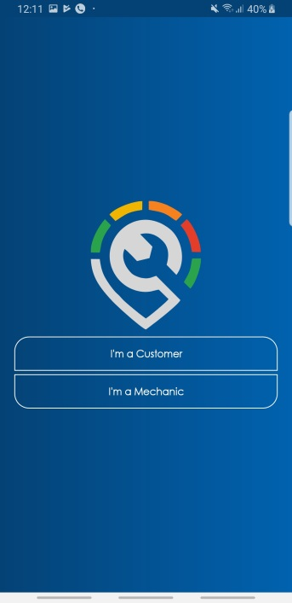

Thereafter the user will proceed to select the login method. As to the user selection, the login activity will appear. The login activity window consists of Email and password text boxes and some user selection functions as shown in the figure.

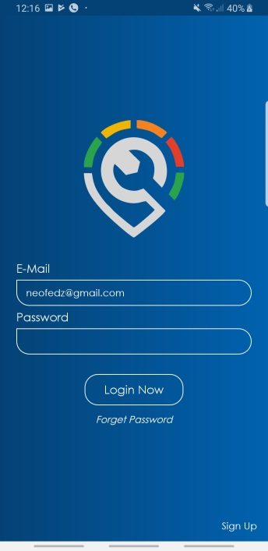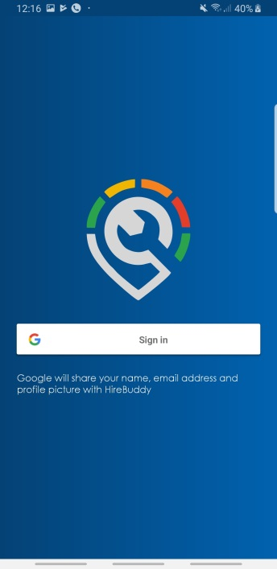

After the login scenario, it will proceed to the significant interface which contains a map, navigation pane and some other objects. Once the user selects the floating button the navigation pane will appear. These components will be changed according to the user type.

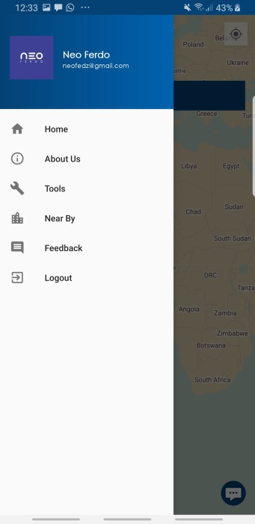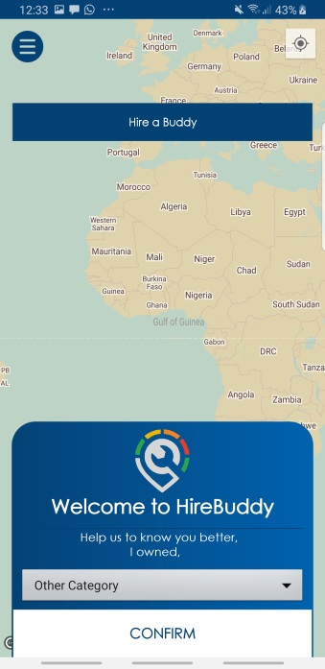

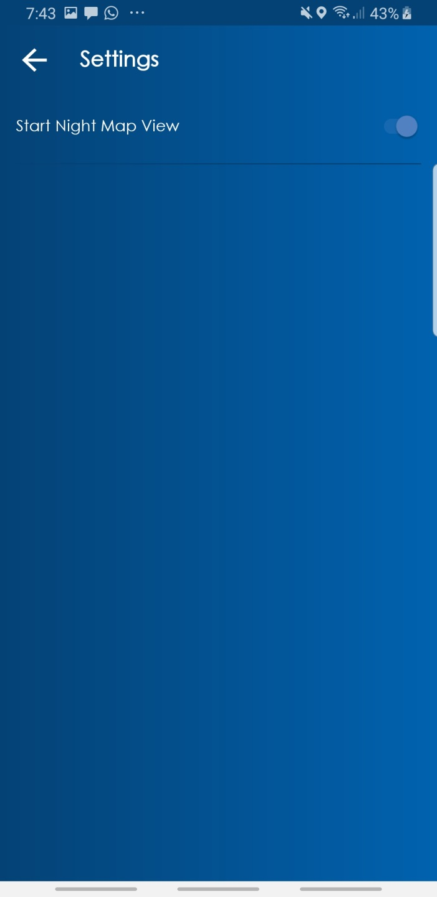The style of the map is getting change according to the system time as shown in the following figures. And the user is able to enable or disable this feature from the application options.

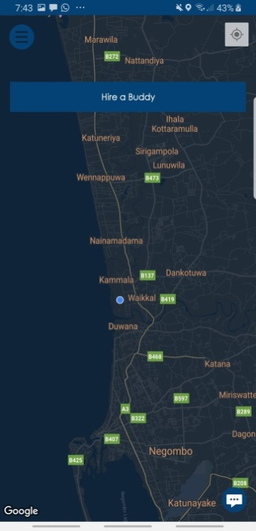

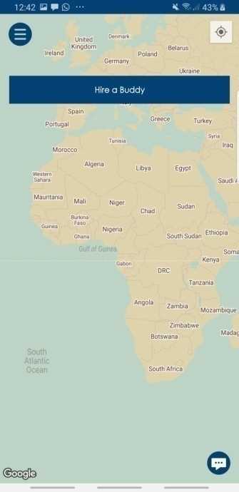

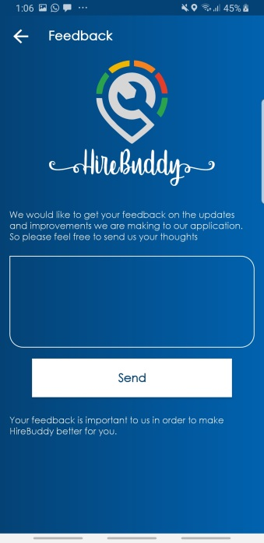There is another interface allocated for getting user feedbacks. Since the project is following Agile Methodology it is important. Therefore the interface is designed in a simplistic manner. And it contains with

When showing nearby Police stations, Car Repair stations and Hospitals it allows the user to select the place, after that as to the selection nearby places will displays. To mark the place the application is using different types of markers.

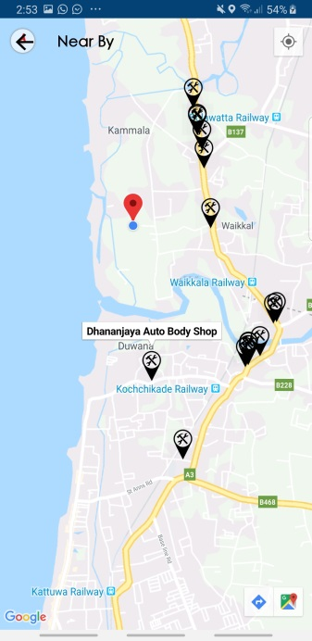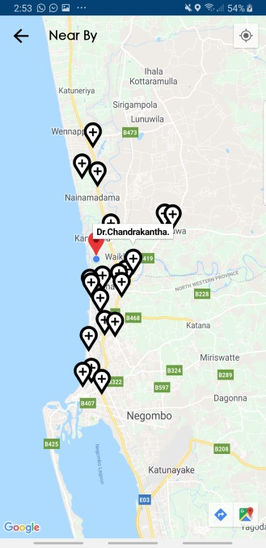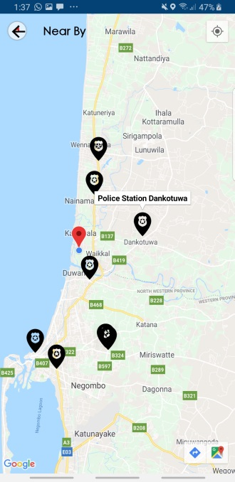

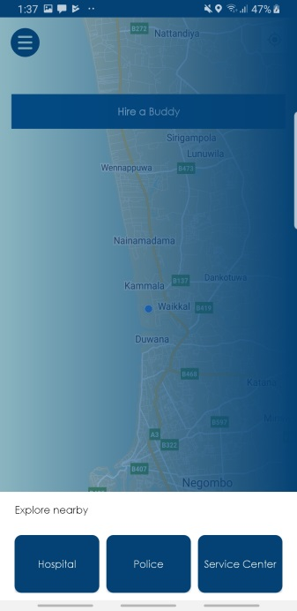

Interfaces were designed to suit any type of display and any display rotation.

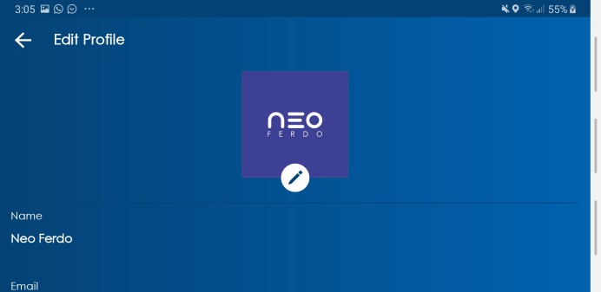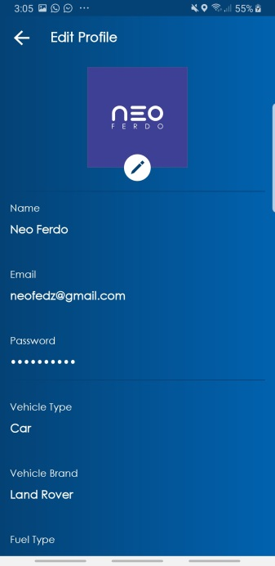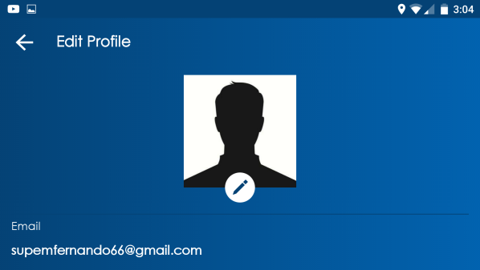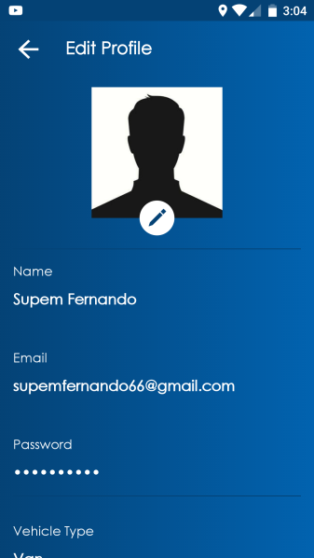

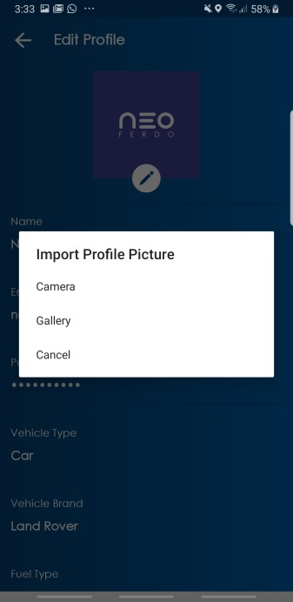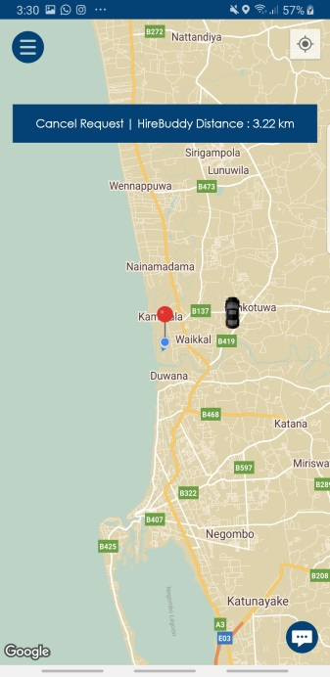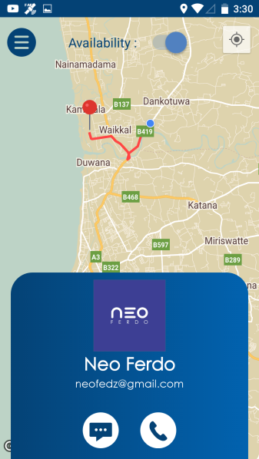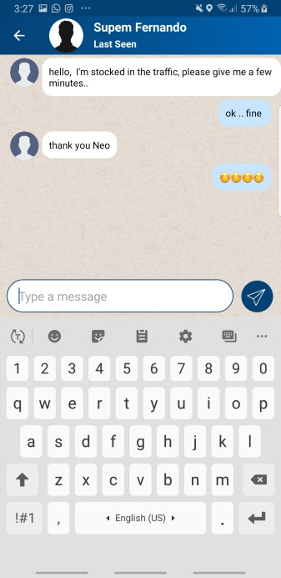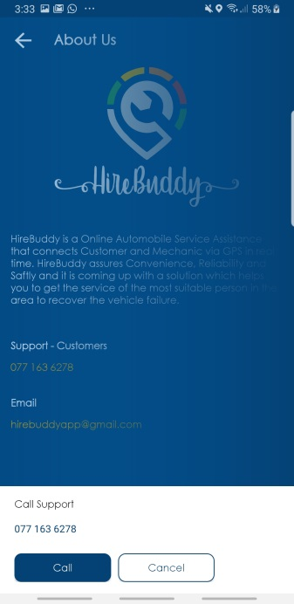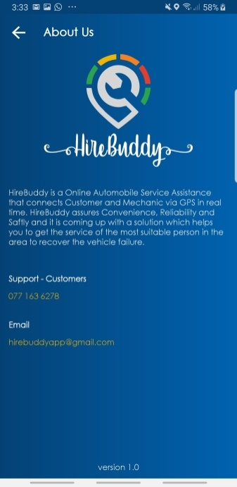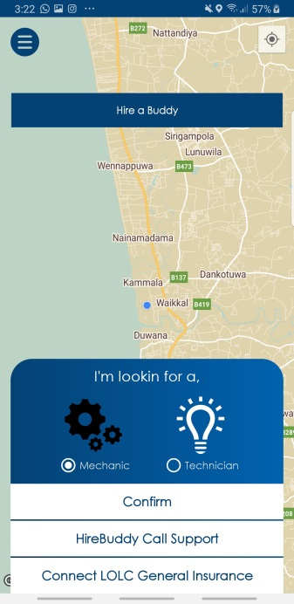Likewise, all the interfaces of the HireBuddy application were designed according to the user-friendly approach.

**3.3.3. Database Design**

Database structure that will be utilized as the plan to store and handle data is called as Database design. The reasons for managing a proper database design is Good application programs can't overcome awful database plans as well as the end user and the database planner choose what data will be kept in the database. In this way keeping up a proper database design is significant. In advance, ER Diagram was made after gathering data requirements.

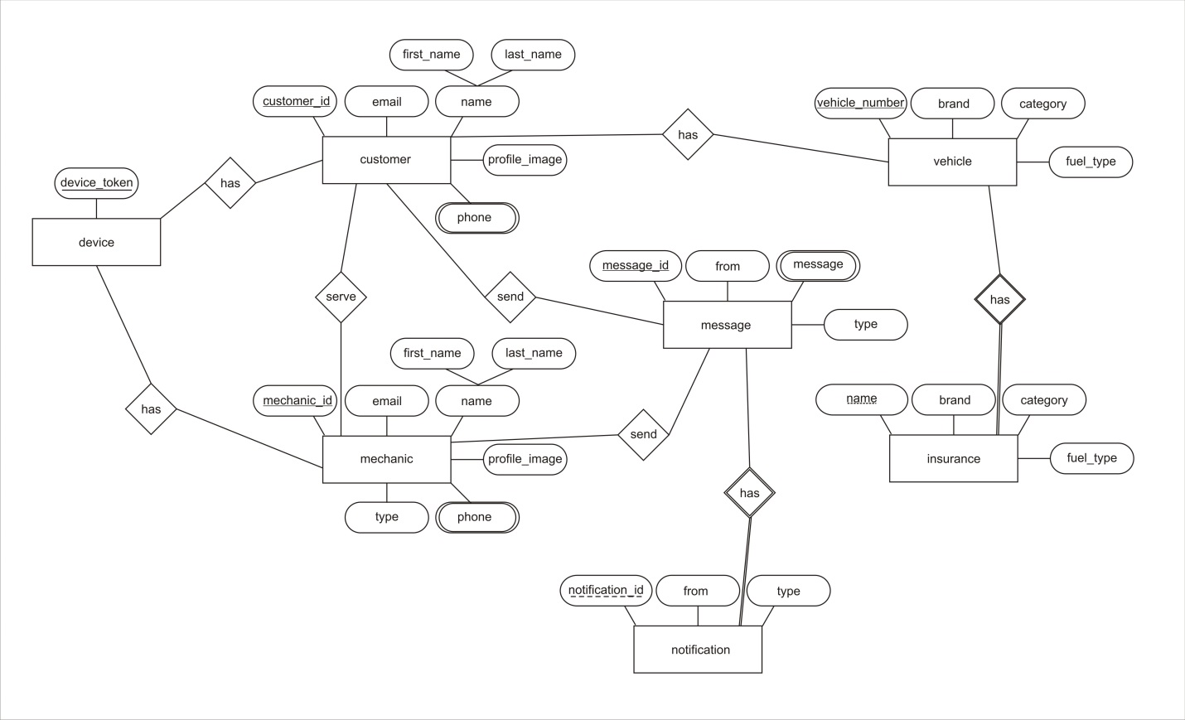

**********************3.4 Implementation**

**Introduction**

Displaying the present framework into a proposed framework is the main purpose of the implementation. This task handled by the plan and given timeline. The created framework depends on Android platform while it works through Android Studio. The product supposed to release sprint by sprint since it follows the Agile Methodology. The project followed OOP features, for example, inheritance, abstraction, encapsulation, and polymorphism to increase the efficiency of the framework. "Google API" and Java Libraries supports for the process development of the project. After the implementation of every one of the sprints, it tested under the unit wise testing technique before the release.

Sprint 1: Ability to login to the system with sign up and sign in Options

Ability of Generating Map and to find current location

Ability to Search a different location on Map

Filtering features

Introducing the system to the market was mainly focused at the release of the first sprint. As well as it gives a basic idea about the upcoming versions of the framework. In this version it enables to find the nearest hospitals, police stations well as the insurance companies.

Sprint 2: Notifications

Ability to calculate the cost

Update information

Online message and call platform

The second sprint introduced many new features to the application. Online calling and messaging feature added in this release as well as this application contains with a unique featured specific cost calculator. There are some other new features too.

Sprint 3: Request and Cancel Orders

Location Service Functions

With the arrival of third sprint the client permits to create and cancel requests as well as some other location administrations.

The final product or the final version completed with all the features. By going through the testing strategies the product had become a zero error and bugs free product. Analyzing the quality of previous versions helped to release a product with good quality.

**Technologies Used**

**JAVA**

Most of the project parts pretend on object-oriented and class-oriented therefore Java language was used as coding language. Since java offers various APIs for the development as well as Java is having a great community is also a great advantage.

**Node.js**

Node.js is a JavaScript runtime environment it enables the infrastructure to create and execute the application system. It’s a simple, versatile, light and cross-platform approach to execute the code segment. It utilizes an event-driven IO model which makes it extremely proficient.

**Android Studio**

Android Studio used as the IDE (Integrated Development Environment) for the HireBuddy system. Android Studio is the official IDE for android based application development and it is built on JetBrains' IntelliJ IDEA software. It provides smooth service to the programmer.

**Android Platform**

Android has been the high accuracy open source platform is the main reason to select it as the running environment for the HireBuddy system. And furthermore, it is easy to popular among the market because as to the statistics most of the individuals were using Android devices. The graphical view of the android platform is as follows.

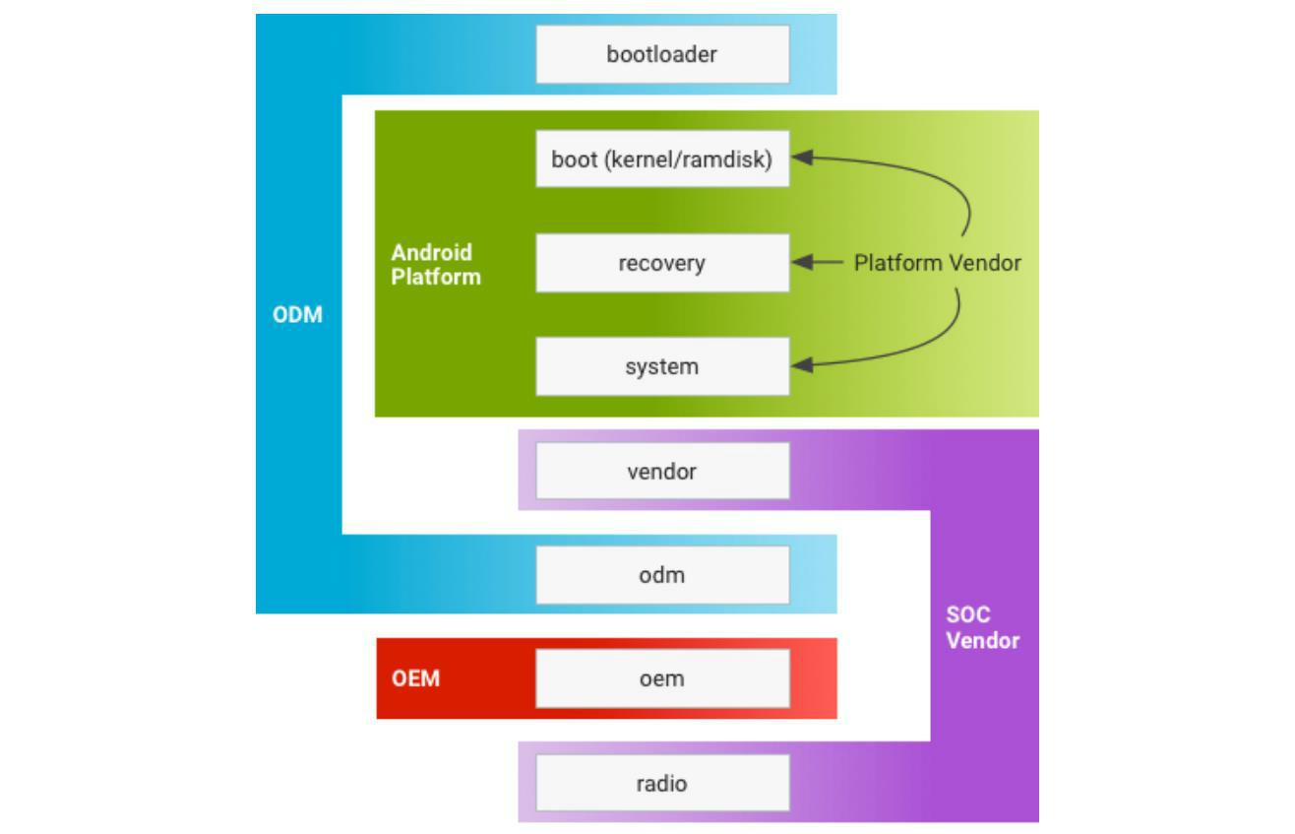

**Firebase**

Firebase consists of multiple services that help developers for their development needs. Firebase is popular because of it useful in building application integrated with a real-time database. Right now, most android based applications are using firebase since its feature. Such as Crash Reporting, authentication, storage capabilities, cloud messaging.

Easy to read documentation
 

3.5 Testing

**3.6 Evaluation**

The evaluation of the proposed system, Online Automobile service platform or “HireBuddy” is based on the feedbacks of a group of exact vehicle users as well as some technicians. This group of evaluators contains some members of my family and some of SLIIT Computing students. I have selected some technicians too. The people that have selected as the evaluators are between 20 to 60 age ranges.

After the proposed system almost developed, the final product has been distributed with the technicians and vehicle users. To collect the feedbacks the system contains a feedback session. It has been added as a function of the application. User will be able to submit their feedback about the application through the feedback session.

According to the feedbacks, most of the technicians and the vehicle users are happy about the “HireBuddy” application as it is user friendly and because of the attractive interfaces. Also it is easy to understand and it won't confuse the fresh users. As indicated by the user opinions they like the functions of the proposed system as it save the time of the people with high efficiency.

The below figure describe the performances of the proposed system base on the exact user’s feedbacks;

|  |  |  |  |  |
| --- | --- | --- | --- | --- |
| **Function** | Excellent | Good | Average | Bad |
|  |  |  |  |  |
| Calculation | **✓** |  |  |  |
|  |  |  |  |  |
| Web search | **✓** |  |  |  |
|  |  |  |  |  |
| Voice to text |  | **✓** |  |  |
|  |  |  |  |  |
| Text detection |  | **✓** |  |  |
|  |  |  |  |  |
| Text to speech | **✓** |  |  |  |
|  |  |  |  |  |
| Interfaces and the | **✓** |  |  |  |
| appearance |  |  |  |  |
|  |  |  |  |  |
|  | *Figure 36:Performences of the application* | |  |  |



63 | P a g e

The following table displays some comments given by the exact uses as indicated by their experiences with “HireBuddy” application.

|  |  |
| --- | --- |
| **No.** | **Comment** |
|  |  |
| 01. | Perfect and invaluable tool for those of us who get overwhelmed by large blocks of |
|  | text |
|  |  |
| 02. | The app is great but it would be better if you add a feature that the scanner should |
|  | detect the hand written equations. However, it is still helpful and hope for development |
|  | on my suggestion. |
|  |  |
| 03. | Best app ever for converting images into text. Tremendously useful for teachers, |
|  | students and visually impaired people. Loved it. |
|  |  |
| 04. | Some Words recognize Wrongly. But it's ok. At least, it's quite better comparison to |
|  | other similar apps. Thanks |
|  |  |
| 05. | This app is awesome! It was really useful and besides from the camera that could solve |
|  | any problem, it also had a regular calculator function and ability. Great work! |
|  |  |
| 06. | it's effective application but It will make a few mistakes depending on text font and |
|  | image quality, but still fantastic. |
|  |  |
| 07. | Application is offering attractive bundle of features. Web search function is my |
|  | favorite. |

1. Really useful... Just as good as a physical calculator. Solving equations with camera would help a lot
   1. The interfaces of this application is user friendly and easy to use. appearance also

nice. Great job.

*Figure 37: Comments given by the users*



64 | P a g e

Chapter 04: Results and Discussions

* **Accuracy and the performance**

“Scan&Math” is mainly focuses to help visually impaired people and the other people also can beneficial through this application in their day-to-day tasks. Since the application uses the latest OCR libraries, the accuracy and the performance are very high. To increase the accuracy of this application image quality has been increased by using suitable image processing techniques. URI (Uniform Resource Identifier) has been used to identify correct path of the image. Because URI is a string which refers directly to the resource.

Always high performance and the effectiveness are the key features of a quality product. With that fact, the interfaces of this product were designed user friendly and easy to use manner to increase user performance through this application. And also image size was reduced before the process. Because process time will depend on size of the image. Therefore, images with small sizes are process fast than the large size of images and that process time will directly affect to the performance of the application. Furthermore, it has been used URI to find location of the image file and it is very fast method than searching file through its path. Likewise, this application used so many strategies to increase performance and the accuracy of the system.

* **Technical problems**

Technical problems are the most common problems which occurs during the software life time. Since the project mainly focuses visually impaired people and had to concern their needs and the daily tasks. When it comes to the development process of the project, initially gathered requirements were insufficient. So it has to gather requirement data



65 | P a g e

again. If the requirements were not good, project will fail and people will hate the result. With that fact conduct another few interviews to gather complete and correct requirements.

Bugs-free software does not exist in the world. As the above statement, when it comes to the testing phase there was an error in orientation of the image. The images capture through OCR camera were always process with incorrect orientation. Therefore, its unable to detect text from the captured images. To overcome from this problem, it has been used EXIFINTERFACE library. And with that library it was able to correct the orientation of the captured image. It cost more time to overcome with the issue and project time plan was deviated. To balance with project time plan, step by step reduce the extra time which allocated to implementation of small functions. With that solution it was able to balance with the project time plan and finish the project before the dead line.

Chapter 05: Conclusion

5.1 Benefits

“Scan&Math” is a product which is developed to help visually impaired people in their daily tasks. But with the performance and the accuracy, all other people also can beneficial from this application. Basically this application scans the text from the digital image and process it in to editable text. Therefore, user able to edit the text and copy past it as the user’s requirement. And also if user required additional information about the scanned text, user able to simply search it on the web through this application. With the use of Scan & Math the user able to work out



66 | P a g e

simple arithmetic problems by capturing an image of the specific equation. Furthermore, application able to give voice output of all scanned texts and the answers which solve by the calculate function. Likewise, it offering package of functions and beneficial for all Scan&Math users.

5.2 Limitations

Currently this application developed to solve simple mathematical equations only. It cannot solve long equations with multiple arithmetic symbols. As discussed in evaluation chapter this feature was a missed part of this application. And also it is unable to capture customized area by targeting single text or the equation. It is one of the main defect of this application and most of the user suggest to add this feature in future. Likewise, these are the main limitations of this application and according to the user feedbacks these functions are willing to develop in future.

5.3 Summery

This is the final thesis report of “Scan&Math” android based application. The report mainly consists of 5 chapters and each chapter described the background processes of the “Scan& Math” application such as project background, requirement gathering and analyzing, design of the project, testing and last evaluation of the project. Moreover, it will provide a detail discussion about the project by highlighting performance, accuracy and the technical problems. As the commencing stage, there were identified 3 main objectives according to fulfill the aim of the project and by successfully achieving each one of them completed the entire project. Even through in some versions failed to complete entire function within the allocated time according to GANTT chart because of some problem occurred and have to overcome with them. But at the



67 | P a g e

end, it has been successfully developed the entire project and evaluate it before the deadline. There were some problems occurred in the development process and manage to overcome with them by following proper testing and coding standards. Likewise, the final result of the project “Scan&Math” will beneficial for the visually impaired people and all other people.

5.5 Feature works

In the future, this application will upload to the google play store and people can beneficial by using this application. And also there is a possibility to release new version by adding fabulous features to the current system. With that fact it is supposed to add modifications such as detect hand written texts, procedure to solve long equations with multiple arithmetic symbols and adding a feature to capture customized area by the user. Likewise, with these features user will able to be more beneficial than the current system.

References

Anandhi, N. and Avudaiammal, R., 2017, April. Segmentation and recognition of text from image using pattern matching. In *Communication and Signal Processing (ICCSP), 2017 International* *Conference on* (pp. 0066-0069). IEEE.

Arik, S.O., Chrzanowski, M., Coates, A., Diamos, G., Gibiansky, A., Kang, Y., Li, X., Miller, J., Raiman, J., Sengupta, S. and Shoeybi, M., 2017. Deep voice: Real-time neural text-to-speech. *arXiv* *preprint arXiv:1702.07825*.



68 | P a g e

Boehm, B.W., 1988. A spiral model of software development and enhancement. *Computer*, *21*(5), pp.61-72.

Brisinello, M., Grbić, R., Pul, M. and Anđelić, T., 2017, September. Improving optical character recognition performance for low quality images. In *ELMAR, 2017 International Symposium* (pp. 167-171). IEEE.

Chandarana, J. and Kapadia, M., 2014. Optical character recognition. *International Journal of* *Emerging Technology and Advanced Engineering*, *4*(5), pp.219-223.

Chandio, A.A., Pickering, M. and Shafi, K., 2018, March. Character classification and recognition for Urdu texts in natural scene images. In *Computing, Mathematics and Engineering Technologies* *(iCoMET), 2018 International Conference on* (pp. 1-6). IEEE.

Du, S., Ibrahim, M., Shehata, M. and Badawy, W., 2013. Automatic license plate recognition (ALPR): A state-of-the-art review. *IEEE Transactions on circuits and systems for video* *technology*, *23*(2), pp.311-325.



69 | P a g e

Fleizach, C.B. and Hudson, R.D., Apple Inc, 2015. *Intelligent text-to-speech conversion*. U.S. Patent 8,996,376.

Hamadneh, I.M. and Al-Masaeed, A., 2015. Math teachers' attitudes towards photo math application in solving mathematical problem using mobile camera. *Educational Research and* *Reviews*, *10*(14), p.1930.

Jaderberg, M., Simonyan, K., Vedaldi, A. and Zisserman, A., 2014. Synthetic data and artificial neural networks for natural scene text recognition. *arXiv preprint arXiv:1406.2227*.

Kakani, B.V., Gandhi, D. and Jani, S., 2017, July. Improved OCR based automatic vehicle number plate recognition using features trained neural network. In *2017 8th International Conference on* *Computing, Communication and Networking Technologies (ICCCNT)* (pp. 1-6). IEEE.

Manwatkar, P.M. and Yadav, S.H., 2015, March. Text recognition from images. In *Innovations in* *Information, Embedded and Communication Systems (ICIIECS), 2015 International Conference on* (pp. 1-6). IEEE.



70 | P a g e

Netzer, Y., Wang, T., Coates, A., Bissacco, A., Wu, B. and Ng, A.Y., 2011, December. Reading digits in natural images with unsupervised feature learning. In *NIPS workshop on deep learning and* *unsupervised feature learning* (Vol. 2011, No. 2, p. 5)

Ochkov, V.F. and Bogomolova, E.P., 2015. Teaching mathematics with mathematical software. *Journal of Humanistic Mathematics*, *5*(1), pp.265-285.

O'malley, S., O'malley, M.H. and Peters, E., Berkeley Speech Tech Inc, 1991. *Text-to-speech* *converter of a facsimile graphic image*. U.S. Patent 4,996,707

Pang, L., Lan, Y., Guo, J., Xu, J., Wan, S. and Cheng, X., 2016, February. Text Matching as Image Recognition. In *AAAI*(pp. 2793-2799).

Pradeepa, K. and Sivitha, M., 2014, December. Optical persona realization of tantrum text sensing, excavation and recognition. In *Computational Intelligence and Computing Research* *(ICCIC), 2014 IEEE International Conference on*(pp. 1-4). IEEE.



71 | P a g e

Pranoto, Y.M., Setyati, E., Pramana, E., Kristian, Y. and Budiman, R., 2016, July. Real time handwriting recognition for mathematic expressions using Hidden Markov Model. In *Intelligent* *Technology and Its Applications (ISITIA), 2016 International Seminar on* (pp. 1-6). IEEE.

Shastry, S., Gunasheela, G., Dutt, T., Vinay, D.S. and Rupanagudi, S.R., 2013, March. “i”—A novel algorithm for optical character recognition (OCR). In *Automation, Computing, Communication,* *Control and Compressed Sensing (iMac4s), 2013 International Multi-Conference on* (pp. 389-393).IEEE.

Song, H., Kalasapur, S., Jeong, S. and Cheng, D., 2009, January. Smartsearch: Situation-aware web search on mobile devices. In *Consumer Communications and Networking Conference, 2009. CCNC* *2009. 6th IEEE* (pp. 1-2). IEEE.

Sonka, M., Hlavac, V. and Boyle, R., 2014. *Image processing, analysis, and machine vision*.

Cengage Learning.

Taylor, P., 2009. *Text-to-speech synthesis*. Cambridge university press.



72 | P a g e

Verma, A., Arora, S. and Verma, P., 2016. OCR Optical Character Recognition. In *7th International* *Conference on Recent Innovations in Science, Engineering and Management*.

World Health Organization. (2018). *Vision impairment and blindness*. [online] Available at: http://www.who.int/news-room/fact-sheets/detail/blindness-and-visual-impairment [Accessed 11 Sep. 2018].

Ye, Q. and Doermann, D., 2015. Text detection and recognition in imagery: A survey. *IEEE* *transactions on pattern analysis and machine intelligence*, *37*(7), pp.1480-1500.

Yin, X.C., Yin, X., Huang, K. and Hao, H.W., 2014. Robust text detection in natural scene images. *IEEE transactions on pattern analysis and machine intelligence*, *36*(5), pp.970-983.

Zhang, Y.Q., Ding, Y., Xiao, J.S., Liu, J. and Guo, Z., 2012. Visibility enhancement using an image filtering approach. *EURASIP Journal on Advances in Signal Processing*, *2012*(1), p.220.



73 | P a g e

Appendix A - Interview Questions

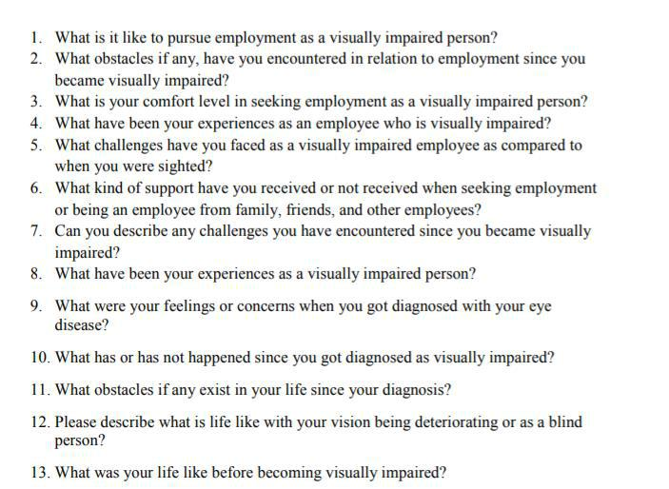

*Figure 38: Interview questions*



74 | P a g e

Appendix B - Evaluation form

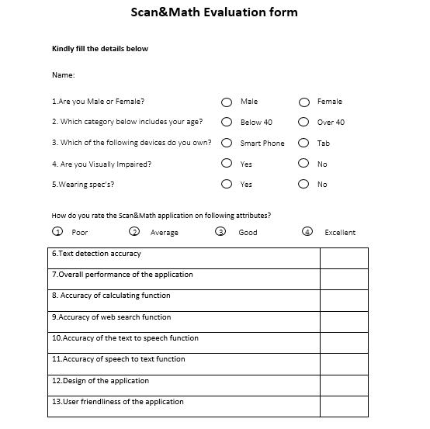

*Figure 39: Evaluation form part 1*



75 | P a g e

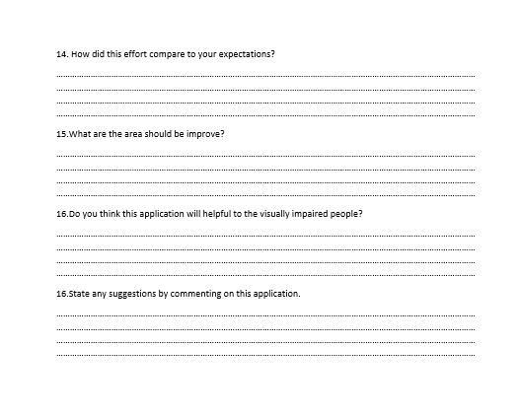

*Figure 40: Evaluation form part 2*



76 | P a g e

Appendix C - Poster

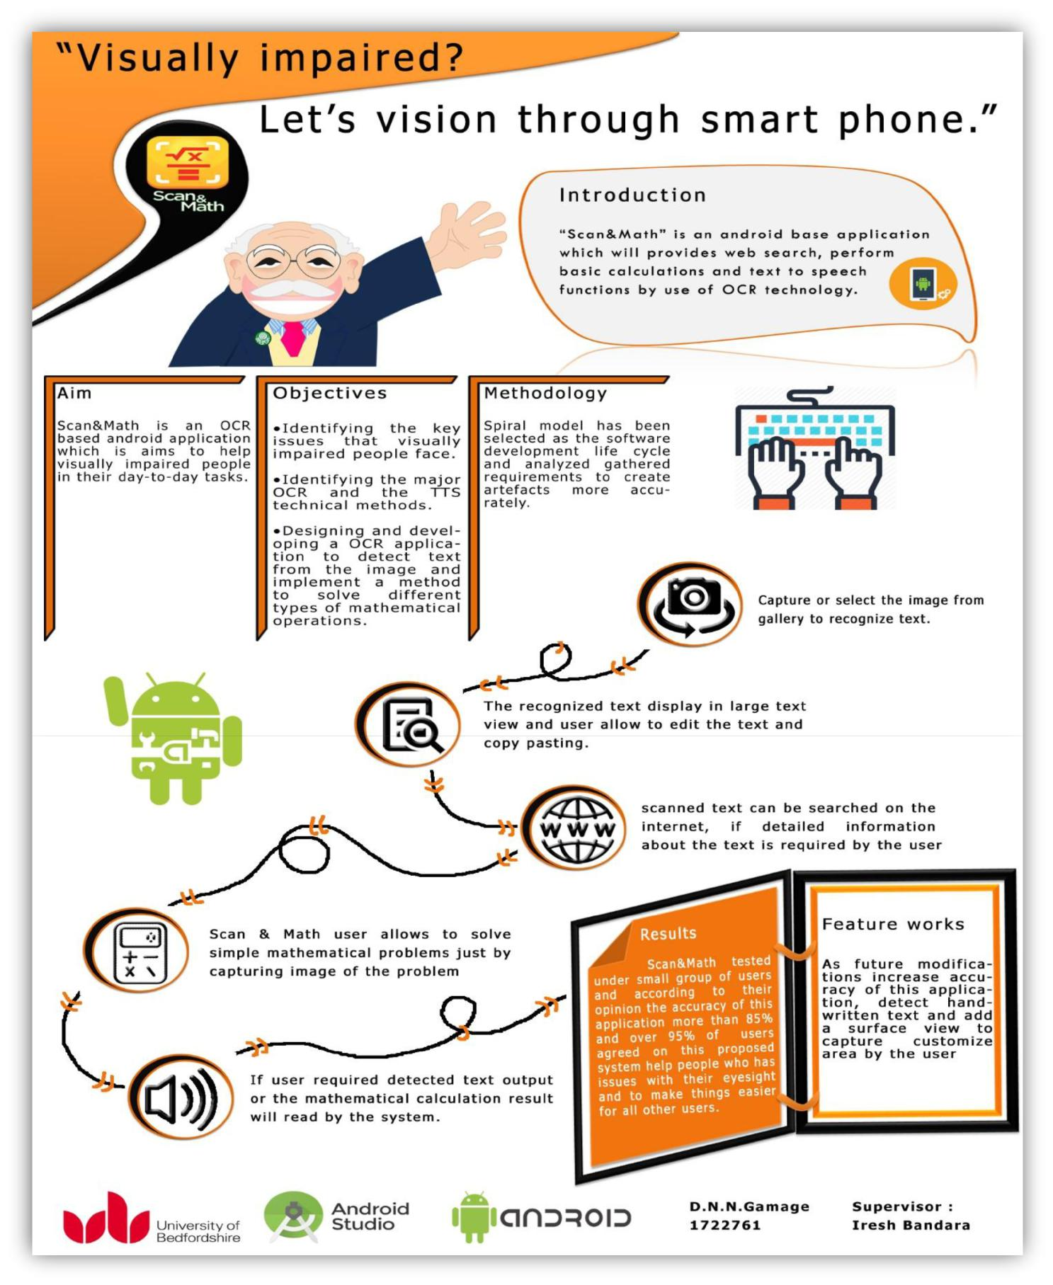

*Figure 41: Poster*



77 | P a g e